UNITED STATES
SECURITIES AND EXCHANGE COMMISSION
Washington, DC 20549

SCHEDULE 14A
(Rule 14a-101)
Proxy Statement Pursuant to Section 14(a) of the
Securities Exchange Act of 1934
Filed by the Registrant ☒
Filed by a Party other than the Registrant ☐
Check the appropriate box:

☐ | Preliminary Proxy Statement

☐ | Confidential, for Use of the Commission Only (as permitted by Rule 14a-6(e)(2))

☐ | Definitive Proxy Statement

☒ | Definitive Additional Materials

☐ | Soliciting Material under § 240.14a-12


nCino, Inc.
(Name of Registrant as Specified in its Charter)
(Name of Person(s) Filing Proxy Statement, if Other Than the Registrant)
Payment of Filing Fee (Check the appropriate box):

☒ | No fee required.

☐ | Fee paid previously with preliminary materials.

☐ | Fee computed on table in exhibit required per Exchange Act Rules 14a-6(i)(1) and 0-11.

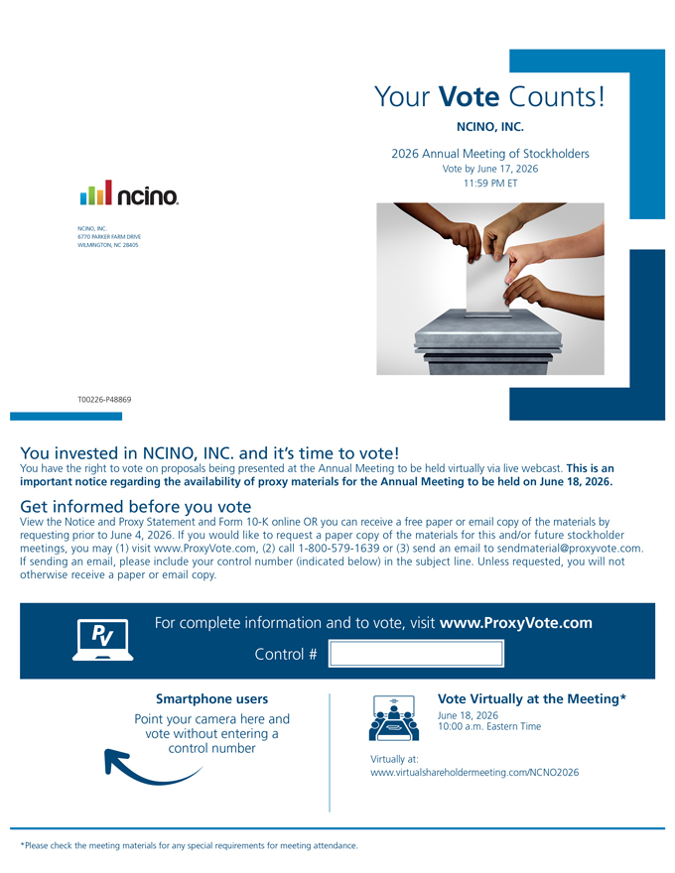
Your Vote Counts!
NCINO, INC.
2026 Annual Meeting of Stockholders
Vote by June 17, 2026
11:59 PM ET
T00226-P48869
For complete information and to vote, visit www.ProxyVote.com
Control #
Smartphone users
Point your camera here and vote without entering a control number
*Please check the meeting materials for any special requirements for meeting attendance.
Vote Virtually at the Meeting*
June 18, 2026
10:00 a.m. Eastern Time
Virtually at:
www.virtualshareholdermeeting.com/NCNO2026
You invested in NCINO, INC. and it’s time to vote!
You have the right to vote on proposals being presented at the Annual Meeting to be held virtually via live webcast. This is an important notice regarding the availability of proxy materials for the Annual Meeting to be held on June 18, 2026.
Get informed before you vote
View the Notice and Proxy Statement and Form 10-K online OR you can receive a free paper or email copy of the materials by requesting prior to June 4, 2026. If you would like to request a paper copy of the materials for this and/or future stockholder meetings, you may (1) visit www.ProxyVote.com, (2) call 1-800-579-1639 or (3) send an email to sendmaterial@proxyvote.com. If sending an email, please include your control number (indicated below) in the subject line. Unless requested, you will not otherwise receive a paper or email copy.

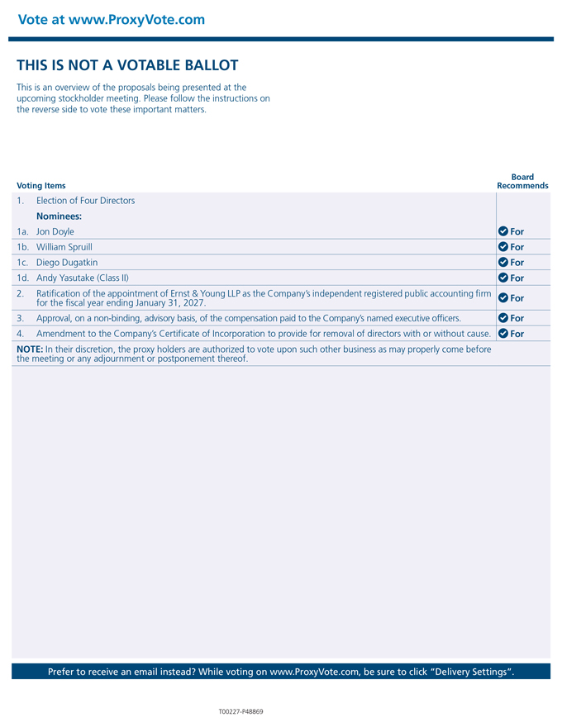
Vote at www.ProxyVote.com
THIS IS NOT A VOTABLE BALLOT
This is an overview of the proposals being presented at the upcoming stockholder meeting. Please follow the instructions on the reverse side to vote these important matters
Prefer to receive an email instead? While voting on www.ProxyVote.com, be sure to click “Delivery Settings”.
T00227-P48869
Board Recommends
Voting Items
1. Election of Four Directors
Nominees:
1a. Jon Doyle For
1b. William Spruill For
1c. Diego Dugatkin For
1d. Andy Yasutake (Class II) For
2. Ratification of the appointment of Ernst & Young LLP as the Company’s independent registered public accounting firm for the fiscal year ending January 31, 2027. For
3. Approval, on a non-binding, advisory basis, of the compensation paid to the Company’s named executive officers. For
4. Amendment to the Company’s Certificate of Incorporation to provide for removal of directors with or without cause. For
NOTE: In their discretion, the proxy holders are authorized to vote upon such other business as may properly come before the meeting or any adjournment or postponement thereof.

