UNITED STATES
SECURITIES AND EXCHANGE COMMISSION
Washington, D.C. 20549

FORM 8-K

CURRENT REPORT
PURSUANT TO SECTION 13 OR 15(d) OF THE SECURITIES EXCHANGE ACT OF 1934

Date of report (Date of earliest event reported): March 31, 2021
nCino, Inc.
(Exact name of registrant as specified in its charter)

 |  |  | Delaware |  |  |  |  |  | 001-39380 |  |  |  |  |  | 46-4353148
 |  |  | (State or other jurisdiction of |  |  |  |  |  | (Commission file number) |  |  |  |  |  | (I.R.S. Employer
 |  |  | incorporation or organization) |  |  |  |  |  |  |  |  |  |  |  | Identification Number)
6770 Parker Farm Drive
Wilmington, North Carolina 28405
(888) 676-2466

(Address, including zip code, and telephone number, including area code, of registrant’s principal executive offices)

Check the appropriate box below if the Form 8-K filing is intended to simultaneously satisfy the filing obligation of the registrant under any of the following provisions:

☐ Written communications pursuant to Rule 425 under the Securities Act (17 CFR 230.425)

☐ Soliciting material pursuant to Rule 14a-12 under the Exchange Act (17 CFR 240.14a-12)

☐ Pre-commencement communications pursuant to Rule 14d-2(b) under the Exchange Act (17 CFR 240.14d-2(b))

☐ Pre-commencement communications pursuant to Rule 13e-4(c) under the Exchange Act (17 CFR 240.13e-4(c))

Securities registered pursuant to Section 12(b) of the Act:

Title of each class |  |  |  |  |  | Trading Symbol(s) |  |  |  |  |  | Name of each exchange on which registered
Common Stock, par value $0.0005 per share |  |  |  |  |  | NCNO |  |  |  |  |  | The Nasdaq Global Select Market

Indicate by check mark whether the registrant is an emerging growth company as defined in Rule 405 of the Securities Act of 1933 (§230.405 of this chapter) or Rule 12b-2 of the Securities Exchange Act of 1934 (§240.12b-2 of this chapter).

Emerging growth company ☒

If an emerging growth company, indicate by check mark if the registrant has elected not to use the extended transition period for complying with any new or revised financial accounting standards provided pursuant to Section 13(a) of the Exchange Act. ☐

Item 2.02 Results of Operations and Financial Condition
On March 31, 2021, nCino, Inc. (the “Company”) issued a press release announcing its financial results for its fourth quarter and fiscal year ended January 31, 2021. A copy of the press release is furnished herewith as Exhibit 99.1 to this Current Report on Form 8-K and is incorporated herein by reference.
The information in Item 2.02 of this Current Report on Form 8-K and the accompanying Exhibit 99.1 shall not be deemed “filed” for purposes of Section 18 of the Securities Exchange Act of 1934, as amended (the “Exchange Act”) or otherwise subject to the liabilities of that section, nor shall it be deemed incorporated by reference in any filing under the Securities Act of 1933, as amended (the “Securities Act”), or the Exchange Act, regardless of any general incorporation language in such filing, unless expressly incorporated by reference in such filing.
Item 7.01 Regulation FD Disclosure
On March 31, 2021, the Company posted investor presentations to its website at www.ncino.com (the “Investor Presentations”). Copies of the Investor Presentations are furnished herewith as Exhibits 99.2 and 99.3 to this Current Report on Form 8-K and are incorporated herein by reference.
The information in Item 7.01 of this Current Report on Form 8-K and the accompanying Exhibits 99.2 and 99.3 shall not be deemed “filed” for purposes of Section 18 of the Exchange Act or otherwise subject to the liabilities of that section, nor shall it be deemed incorporated by reference in any filing under the Securities Act or the Exchange Act, regardless of any general incorporation language in such filing, unless expressly incorporated by reference in such filing. By furnishing the information contained in the Investor Presentations, the Company makes no admission as to the materiality of any information in the Investor Presentations that is required to be disclosed solely by reason of Regulation FD.
Item 9.01 Financial Statements and Exhibits
(d) Exhibits
Exhibit No. |  |  | Description
99.1 |  |  | Press release of nCino, Inc. dated March 31, 2021 (furnished and not filed).
99.2 |  |  | Q4 and FY 2021 Earnings Presentation dated March 31, 2021 (furnished and not filed).
99.3 |  |  | nCino Company Overview dated March 31, 2021 (furnished and not filed).
104 |  |  | Cover Page Interactive Data File (embedded within the Inline XBRL document)

SIGNATURES

Pursuant to the requirements of the Securities Exchange Act of 1934, the registrant has duly caused this report to be signed on its behalf by the undersigned hereunto duly authorized.

 |  |  |  |  |  | nCino, Inc.
Date: March 31, 2021 |  |  | By: |  |  |  |  |  | /s/ David Rudow
David Rudow
Chief Financial Officer



nCino Reports Fourth Quarter and Fiscal Year 2021 Financial Results
Fiscal Year 2021 Total Revenues of $204.3M, up 48% year-over-year; Q4 Total Revenues of $56.6M, up 47% year-over-year
Fiscal Year 2021 Subscription Revenues of $162.4M, up 57% year-over-year; Q4 Subscription Revenues of $45.0M, up 43% year-over-year

WILMINGTON, N.C. – March 31, 2021 – nCino, Inc. (NASDAQ: NCNO), a pioneer in cloud banking and digital transformation solutions for the global financial services industry, today announced financial results for its fourth quarter and fiscal year ended January 31, 2021.

“I am extremely pleased with the end to the year as we closed a record amount of business in the quarter while building one of the largest pipelines in the Company’s history, with over 50% of the pipeline reflecting international opportunities,” said Pierre Naudé, CEO of nCino. “We took a record number of retail customers live, closed multiple retail cross-sell opportunities, and increased our subscription revenue retention rate for the year to 155%. We also added new logos in both the U.S. and international markets, including a continental European deal with one of the largest commercial banks in the Baltics, along with several deals for Automated Spreading and Portfolio Analytics on our nIQ analytics platform.”

Naudé continued, “I am incredibly proud of the hard work, dedication and commitment from the nCino team over the past year to support our growing global customer base, and we are just getting started. Our success in the fourth quarter positions us for another strong year as we help financial institutions around the globe adopt a cloud strategy so they can compete in today’s remote, digital-first environment.”

Financial Highlights
•Revenues: Total revenues for the fourth quarter were $56.6 million, a 47% increase from $38.5 million in the fourth quarter of fiscal 2020. Subscription revenues for the fourth quarter were $45.0 million, up from $31.5 million one year ago, an increase of 43%. Total revenues for fiscal year 2021 were $204.3 million, a 48% increase from $138.2 million in fiscal year 2020. Subscription revenues for fiscal year 2021 were $162.4 million, up from $103.3 million one year ago, an increase of 57%.
•Loss from Operations: GAAP loss from operations in the fourth quarter was ($13.9) million compared to ($10.0) million in the same quarter of fiscal 2020. Non-GAAP operating loss in the quarter was ($7.5) million compared to ($8.1) million in the fourth quarter of fiscal 2020. GAAP loss from operations for fiscal year 2021 was ($42.6) million compared to ($28.2) million in fiscal year 2020. Non-GAAP operating loss for fiscal year 2021 was ($14.2) million compared to ($20.7) million last fiscal year.
•Net Loss Attributable to nCino: GAAP net loss attributable to nCino in the fourth quarter was ($12.1) million compared to ($9.6) million in the fourth quarter of fiscal 2020. Non-GAAP net loss attributable to nCino in the fourth quarter was ($5.7) million compared to ($7.7) million in the fourth quarter of fiscal 2020. GAAP net loss attributable to nCino for fiscal year 2021 was ($40.5) million compared to ($27.6) million in fiscal year 2020. Non-GAAP net loss attributable to nCino for fiscal year 2021 was ($12.1) million compared to ($20.1) million last fiscal year.
•Net Loss Attributable to nCino per Share: GAAP net loss attributable to nCino in the fourth quarter was ($0.13) per share compared to ($0.12) per share in the fourth quarter of fiscal 2020. Non-GAAP net loss attributable to nCino in the fourth quarter was ($0.06) per share compared to ($0.10) per share in the fourth quarter of fiscal 2020. GAAP net loss attributable to nCino for fiscal year 2021 was ($0.46) per share compared to ($0.35) per share in fiscal year 2020. Non-GAAP net loss attributable to nCino for fiscal year 2021 was ($0.14) per share compared to ($0.26) per share last fiscal year.
•Cash: Cash and cash equivalents were $371.4 million as of January 31, 2021.

Recent Business Highlights
•Customer Expansion: Subscription revenue retention rate for fiscal 2021 increased to 155% from 147% in fiscal 2020.
•Increasing Customer Count and Size: Ended fiscal 2021 with over 1,260 customers versus over 1,180 for fiscal 2020. For fiscal 2021, 224 customers generated subscription revenues greater than $100,000 of which 36 had subscription revenues greater than $1 million compared to 161 and 21 customers, respectively, for fiscal 2020.
•Continued Commercial Market Leadership: Added three Farm Credit System deals and renewed and expanded relationships with two regional financial institutions in the U.S., at $15 billion and $20 billion in assets, and with two top 10 Canadian financial institutions.
•nIQ Customer Wins: Ended the quarter with five customers on Automated Spreading and 28 joint nCino Bank Operating System and Portfolio Analytics customers, including the largest joint customer to-date, an $8 billion-asset regional bank.
•Record Retail Go-Lives: Took a record number of financial institutions live on nCino’s Retail Lending solution, including the U.S. arm of a $50 billion bank, a $30 billion U.S. regional bank, and a $12 billion-asset Canadian Credit Union.
•Expanded Customer Footprint Following M&A: Selected for Commercial Lending by Truist Bank and First Horizon Bank after these customers completed mergers with existing nCino customers, SunTrust and IBERIABANK, respectively.
•International Wins: Signed a large expansion deal for Commercial Lending with our first customer in Continental Europe.
•PPP Revenues Benefit Year: Supported 98 financial institutions in the U.S. and U.K. through their PPP and CBILS programs, recording approximately $13.5 million in related subscription revenues during fiscal 2021.

Financial Outlook
nCino is providing guidance for its first quarter ending April 30, 2021 as follows:
•Total revenues between $59 million and $60 million.
•Subscription revenues between $48.5 million and $49.5 million.
•Professional services revenues between $9.5 and $10.5 million.
•Non-GAAP operating loss between ($4.0) million and ($5.0) million.
•Non-GAAP net loss attributable to nCino per share of ($0.04) to ($0.05).

nCino is providing guidance for its fiscal year 2022 ending January 31, 2022 as follows:
•Total revenues between $253 million and $255 million.
•Subscription revenues between $209 million and $211 million.
•Professional services revenues between $42 million and $44 million.
•Non-GAAP operating loss between ($23.0) million and ($25.0) million.
•Non-GAAP net loss attributable to nCino per share of ($0.24) to ($0.26).
Conference Call
nCino will host a conference call at 4:30 p.m. ET today to discuss its financial results and outlook with the investment community. The conference call will be available via live webcast and replay at the Investor Relations section of nCino’s website: https://investor.ncino.com/news-events/events-and-presentations.
About nCino
nCino (NASDAQ: NCNO) is the worldwide leader in cloud banking. The nCino Bank Operating System® empowers financial institutions with scalable technology to help them achieve revenue growth, greater efficiency, cost savings and regulatory compliance. In a digital-first world, nCino's single digital platform enhances the employee and client experience to enable financial institutions to more effectively onboard

new clients, make loans and manage the entire loan life cycle, and open deposit and other accounts across lines of business and channels. Transforming how financial institutions operate through innovation, reputation and speed, nCino works with more than 1,200 financial institutions globally, whose assets range in size from $30 million to more than $2 trillion. For more information, visit: www.ncino.com.
Forward-Looking Statements
This press release contains forward-looking statements about nCino's financial and operating results, which include statements regarding nCino’s future performance, outlook, and guidance, the assumptions underlying those statements, the benefits from the use of nCino’s solutions, our strategies, and general business conditions. Forward-looking statements generally include actions, events, results, strategies and expectations and are often identifiable by use of the words “believes,” “expects,” “intends,” “anticipates,” “plans,” “seeks,” “estimates,” “projects,” “may,” “will,” “could,” “might,” or “continues” or similar expressions and the negatives thereof. Any forward-looking statements contained in this press release are based upon nCino’s historical performance and its current plans, estimates, and expectations and are not a representation that such plans, estimates, or expectations will be achieved. These forward-looking statements represent nCino’s expectations as of the date of this press release. Subsequent events may cause these expectations to change and, except as may be required by law, nCino does not undertake any obligation to update or revise these forward-looking statements. These forward-looking statements are subject to known and unknown risks and uncertainties that may cause actual results to differ materially including, but not limited to: (i) risks associated with the impact of the COVID-19 pandemic, including the impact to the financial services industry, the impact on general economic conditions and the impact of government responses, restrictions, and actions; (ii) breaches in our security measures or unauthorized access to our customers’ or their clients' data; (iii) the accuracy of management’s assumptions and estimates; (iv) our ability to attract new customers and succeed in having current customers expand their use of our solutions; (v) competitive factors, including pricing pressures, consolidation among competitors, entry of new competitors, the launch of new products and marketing initiatives by our competitors, and difficulty securing rights to access or integrate with third party products or data used by our customers; (vi) the rate of adoption of our newer solutions and the results of our efforts to sustain or expand the use and adoption of our more established solutions; (vii) fluctuation of our results of operations, which may make period-to-period comparisons less meaningful; (viii) our ability to manage our growth effectively including expanding outside of the United States; (ix) adverse changes in our relationship with Salesforce; (x) our ability to successfully acquire new companies and/or integrate acquisitions into our existing organization; (xi) the loss of one or more customers, particularly any of our larger customers, or a reduction in the number of users our customers purchase access and use rights for; (xii) system unavailability, system performance problems, or loss of data due to disruptions or other problems with our computing infrastructure or the infrastructure we rely on that is operated by third parties; (xiii) our ability to maintain our corporate culture and attract and retain highly skilled employees; (xiv) adverse changes in the financial services industry, including as a result of customer consolidation; (xv) adverse changes in economic, regulatory, or market conditions; and (xvi) the outcome and impact of legal proceedings and related expenses.
Additional risks and uncertainties that could affect nCino’s business and financial results are included in our reports filed with the U.S. Securities and Exchange Commission (available on our web site at www.ncino.com or the SEC's web site at www.sec.gov). Further information on potential risks that could affect actual results will be included in other filings nCino makes with the SEC from time to time.

nCino, Inc.

CONDENSED CONSOLIDATED BALANCE SHEETS
(In thousands)
(Unaudited)
 |  |  | January 31, 2020 |  |  |  |  |  | January 31, 2021
Assets
Current assets
Cash and cash equivalents |  |  | $ | 91,184 |  |  |  |  | $ | 371,425
Accounts receivable, net |  |  | 34,205 |  |  |  |  |  | 55,517
Accounts receivable, related parties |  |  | 9,201 |  |  |  |  |  | —
Costs capitalized to obtain revenue contracts, current portion, net |  |  | 3,608 |  |  |  |  |  | 4,864
Prepaid expenses and other current assets |  |  | 7,079 |  |  |  |  |  | 10,425
Total current assets |  |  | 145,277 |  |  |  |  |  | 442,231
Property and equipment, net |  |  | 13,477 |  |  |  |  |  | 29,943
Costs capitalized to obtain revenue contracts, noncurrent, net |  |  | 7,000 |  |  |  |  |  | 10,191
Goodwill |  |  | 55,840 |  |  |  |  |  | 57,149
Intangible assets, net |  |  | 26,093 |  |  |  |  |  | 23,137
Other long-term assets |  |  | 2,464 |  |  |  |  |  | 750
Total assets |  |  | $ | 250,151 |  |  |  |  | $ | 563,401
Liabilities, redeemable non-controlling interest, and stockholders’ equity
Current liabilities
Accounts payable |  |  | $ | 1,258 |  |  |  |  | $ | 1,634
Accounts payable, related parties |  |  | 3,408 |  |  |  |  |  | 4,363
Accrued commissions |  |  | 7,862 |  |  |  |  |  | 12,500
Other accrued expenses |  |  | 4,922 |  |  |  |  |  | 7,527
Deferred rent, current portion |  |  | 183 |  |  |  |  |  | 203
Deferred revenue, current portion |  |  | 50,929 |  |  |  |  |  | 89,141
Deferred revenue, current portion, related parties |  |  | 8,013 |  |  |  |  |  | —
Financing obligation, current portion |  |  | — |  |  |  |  |  | 324
Total current liabilities |  |  | 76,575 |  |  |  |  |  | 115,692
Deferred income taxes, noncurrent |  |  | 194 |  |  |  |  |  | 368
Deferred rent, noncurrent |  |  | 1,558 |  |  |  |  |  | 1,486
Deferred revenue, noncurrent |  |  | — |  |  |  |  |  | 946
Financing obligation, noncurrent |  |  | — |  |  |  |  |  | 15,939
Other long-term liabilities |  |  | 195 |  |  |  |  |  | —
Total liabilities |  |  | 78,522 |  |  |  |  |  | 134,431
Commitments and contingencies
Redeemable non-controlling interest |  |  | 4,356 |  |  |  |  |  | 3,791
Stockholders’ equity
Common stock |  |  | 41 |  |  |  |  |  | 47
Additional paid-in capital |  |  | 288,564 |  |  |  |  |  | 585,956
Accumulated other comprehensive (loss) income |  |  | (408) |  |  |  |  |  | 240
Accumulated deficit |  |  | (120,924) |  |  |  |  |  | (161,064)
Total stockholders’ equity |  |  | 167,273 |  |  |  |  |  | 425,179
Total liabilities, redeemable non-controlling interest, and stockholders’ equity |  |  | $ | 250,151 |  |  |  |  | $ | 563,401

nCino, Inc.

CONDENSED CONSOLIDATED STATEMENTS OF OPERATIONS
(In thousands, except share and per share data)
(Unaudited)
 |  |  | Three Months Ended January 31, |  |  |  |  |  |  |  |  |  |  |  | Fiscal Year Ended January 31,
 |  |  | 2020 |  |  |  |  |  | 2021 |  |  |  |  |  | 2020 |  |  |  |  |  | 2021
Revenues
Subscription |  |  | $ | 31,450 |  |  |  |  | $ | 44,978 |  |  |  |  | $ | 103,265 |  |  |  |  | $ | 162,439
Professional services |  |  | 7,054 |  |  |  |  |  | 11,609 |  |  |  |  |  | 34,915 |  |  |  |  |  | 41,854
Total revenues |  |  | 38,504 |  |  |  |  |  | 56,587 |  |  |  |  |  | 138,180 |  |  |  |  |  | 204,293
Cost of revenues
Subscription1 |  |  | 9,234 |  |  |  |  |  | 13,570 |  |  |  |  |  | 31,062 |  |  |  |  |  | 47,969
Professional services1 |  |  | 9,139 |  |  |  |  |  | 10,598 |  |  |  |  |  | 33,008 |  |  |  |  |  | 40,166
Total cost of revenues |  |  | 18,373 |  |  |  |  |  | 24,168 |  |  |  |  |  | 64,070 |  |  |  |  |  | 88,135
Gross profit |  |  | 20,131 |  |  |  |  |  | 32,419 |  |  |  |  |  | 74,110 |  |  |  |  |  | 116,158
Gross margin % |  |  | 52 |  | % |  |  |  | 57 |  | % |  |  |  | 54 |  | % |  |  |  | 57 |  | %
Operating expenses
Sales and marketing1 |  |  | 13,370 |  |  |  |  |  | 17,704 |  |  |  |  |  | 44,440 |  |  |  |  |  | 59,731
Research and development1 |  |  | 10,132 |  |  |  |  |  | 16,929 |  |  |  |  |  | 35,304 |  |  |  |  |  | 58,263
General and administrative1 |  |  | 6,640 |  |  |  |  |  | 11,642 |  |  |  |  |  | 22,536 |  |  |  |  |  | 40,772
Total operating expenses |  |  | 30,142 |  |  |  |  |  | 46,275 |  |  |  |  |  | 102,280 |  |  |  |  |  | 158,766
Loss from operations |  |  | (10,011) |  |  |  |  |  | (13,856) |  |  |  |  |  | (28,170) |  |  |  |  |  | (42,608)
Non-operating income (expense)
Interest income |  |  | 306 |  |  |  |  |  | 72 |  |  |  |  |  | 988 |  |  |  |  |  | 361
Interest expense |  |  | — |  |  |  |  |  | (130) |  |  |  |  |  | — |  |  |  |  |  | (130)
Other income (expense), net |  |  | 70 |  |  |  |  |  | 1,356 |  |  |  |  |  | 33 |  |  |  |  |  | 1,693
Loss before income tax expense |  |  | (9,635) |  |  |  |  |  | (12,558) |  |  |  |  |  | (27,149) |  |  |  |  |  | (40,684)
Income tax expense |  |  | 90 |  |  |  |  |  | (123) |  |  |  |  |  | 586 |  |  |  |  |  | 586
Net loss |  |  | (9,725) |  |  |  |  |  | (12,435) |  |  |  |  |  | (27,735) |  |  |  |  |  | (41,270)
Net loss attributable to redeemable non-controlling interest |  |  | (81) |  |  |  |  |  | (430) |  |  |  |  |  | (141) |  |  |  |  |  | (1,130)
Adjustment attributable to redeemable non-controlling interest |  |  | — |  |  |  |  |  | 53 |  |  |  |  |  | — |  |  |  |  |  | 396
Net loss attributable to nCino, Inc. |  |  | $ | (9,644) |  |  |  |  | $ | (12,058) |  |  |  |  | $ | (27,594) |  |  |  |  | $ | (40,536)
Net loss per share attributable to nCino, Inc.:
Basic and diluted |  |  | $ | (0.12) |  |  |  |  | $ | (0.13) |  |  |  |  | $ | (0.35) |  |  |  |  | $ | (0.46)
Weighted average number of common shares outstanding:
Basic and diluted |  |  | 81,402,156 |  |  |  |  |  | 92,789,559 |  |  |  |  |  | 78,316,794 |  |  |  |  |  | 87,678,323
1Includes stock-based compensation expense as follows:
 |  |  | Three Months Ended January 31, |  |  |  |  |  |  |  |  |  |  |  | Fiscal Year Ended January 31,
 |  |  | 2020 |  |  |  |  |  | 2021 |  |  |  |  |  | 2020 |  |  |  |  |  | 2021
Cost of subscription revenues |  |  | $ | 69 |  |  |  |  | $ | 138 |  |  |  |  | $ | 277 |  |  |  |  | $ | 576
Cost of professional services revenues |  |  | 302 |  |  |  |  |  | 874 |  |  |  |  |  | 1,240 |  |  |  |  |  | 4,232
Sales and marketing |  |  | 314 |  |  |  |  |  | 1,372 |  |  |  |  |  | 1,260 |  |  |  |  |  | 6,190
Research and development |  |  | 319 |  |  |  |  |  | 1,057 |  |  |  |  |  | 1,245 |  |  |  |  |  | 5,463
General and administrative |  |  | 59 |  |  |  |  |  | 2,154 |  |  |  |  |  | 1,723 |  |  |  |  |  | 8,747
Total stock-based compensation expense |  |  | $ | 1,063 |  |  |  |  | $ | 5,595 |  |  |  |  | $ | 5,745 |  |  |  |  | $ | 25,208

nCino, Inc.

CONDENSED CONSOLIDATED STATEMENTS OF CASH FLOWS
(In thousands)
(Unaudited)
 |  |  | Fiscal Year Ended January 31,
 |  |  | 2020 |  |  |  |  |  | 2021
Cash flows from operating activities
Net loss attributable to nCino, Inc. |  |  | $ | (27,594) |  |  |  |  | $ | (40,536)
Net loss and adjustment attributable to redeemable non-controlling interest |  |  | (141) |  |  |  |  |  | (734)
Net loss |  |  | (27,735) |  |  |  |  |  | (41,270)
Adjustments to reconcile net loss to net cash provided by (used in) operating activities:
Depreciation and amortization |  |  | 4,609 |  |  |  |  |  | 7,431
Amortization of costs capitalized to obtain revenue contracts |  |  | 3,243 |  |  |  |  |  | 4,682
Stock-based compensation |  |  | 5,745 |  |  |  |  |  | 25,208
Deferred income taxes |  |  | 195 |  |  |  |  |  | 168
Provision for (recovery of) bad debt |  |  | (105) |  |  |  |  |  | 100
Net foreign currency gains |  |  | — |  |  |  |  |  | (1,691)
Change in operating assets and liabilities:
Accounts receivable |  |  | (9,289) |  |  |  |  |  | (20,614)
Accounts receivable, related parties |  |  | (4,867) |  |  |  |  |  | 9,201
Costs capitalized to obtain revenue contracts |  |  | (5,631) |  |  |  |  |  | (8,967)
Prepaid expenses and other assets |  |  | (1,628) |  |  |  |  |  | (3,342)
Accounts payable and accrued expenses and other liabilities |  |  | 2,286 |  |  |  |  |  | 7,086
Accounts payable, related parties |  |  | 1,184 |  |  |  |  |  | 956
Deferred rent |  |  | 1,045 |  |  |  |  |  | (52)
Deferred revenue |  |  | 20,873 |  |  |  |  |  | 38,339
Deferred revenue, related parties |  |  | 1,077 |  |  |  |  |  | (8,013)
Net cash provided by (used in) operating activities |  |  | (8,998) |  |  |  |  |  | 9,222
Cash flows from investing activities
Acquisition of business, net of cash acquired |  |  | (52,267) |  |  |  |  |  | —
Purchases of property and equipment |  |  | (5,760) |  |  |  |  |  | (4,338)
Net cash used in investing activities |  |  | (58,027) |  |  |  |  |  | (4,338)
Cash flows from financing activities
Proceeds from initial public offering, net of underwriting discounts and commissions |  |  | — |  |  |  |  |  | 268,375
Payments of costs related to initial public offering |  |  | — |  |  |  |  |  | (2,765)
Investment from redeemable non-controlling interest |  |  | 4,513 |  |  |  |  |  | —
Proceeds from stock issuance |  |  | 80,000 |  |  |  |  |  | —
Stock issuance costs |  |  | (52) |  |  |  |  |  | —
Payments of deferred costs |  |  | (1,412) |  |  |  |  |  | —
Exercise of stock options |  |  | 1,042 |  |  |  |  |  | 8,745
Contingent consideration payments |  |  | — |  |  |  |  |  | (197)
Principal payments on financing obligation |  |  | — |  |  |  |  |  | (37)
Net cash provided by financing activities |  |  | 84,091 |  |  |  |  |  | 274,121
Effect of foreign currency exchange rate changes on cash and cash equivalents |  |  | (229) |  |  |  |  |  | 1,236
Net increase in cash and cash equivalents |  |  | 16,837 |  |  |  |  |  | 280,241
Cash and cash equivalents, beginning of period |  |  | 74,347 |  |  |  |  |  | 91,184
Cash and cash equivalents, end of period |  |  | $ | 91,184 |  |  |  |  | $ | 371,425

Non-GAAP Financial Measures
In nCino’s public disclosures, nCino has provided non-GAAP measures, which are measurements of financial performance that have not been prepared in accordance with generally accepted accounting principles in the United States, or GAAP. In addition to its GAAP measures, nCino uses these non-GAAP financial measures internally for budgeting and resource allocation purposes and in analyzing our financial results. For the reasons set forth below, nCino believes that excluding the following items provides information that is helpful in understanding our operating results, evaluating our future prospects, comparing our financial results across accounting periods, and comparing our financial results to our peers, many of which provide similar non-GAAP financial measures.
•Stock-Based Compensation Expenses. nCino excludes stock-based compensation expenses primarily because they are non-cash expenses that nCino excludes from our internal management reporting processes. nCino’s management also finds it useful to exclude these expenses when they assess the appropriate level of various operating expenses and resource allocations when budgeting, planning and forecasting future periods. Moreover, because of varying available valuation methodologies, subjective assumptions and the variety of award types that companies can use, nCino believes excluding stock-based compensation expenses allows investors to make meaningful comparisons between our recurring core business operating results and those of other companies.
•Amortization of Purchased Intangibles. nCino incurs amortization expense for purchased intangible assets in connection with acquisitions of certain businesses and technologies. Because these costs have already been incurred, cannot be recovered, are non-cash, and are affected by the inherent subjective nature of purchase price allocations, nCino excludes these expenses for our internal management reporting processes. nCino’s management also finds it useful to exclude these charges when assessing the appropriate level of various operating expenses and resource allocations when budgeting, planning and forecasting future periods. Although nCino excludes amortization expense for purchased intangibles from these non-GAAP measures, management believes it is important for investors to understand that such intangible assets were recorded as part of purchase accounting and contribute to revenue generation.
In addition, our non-GAAP guidance excludes expenses related to the government antitrust investigation and related civil action disclosed in our SEC filings as we do not believe these matters relate to the operating business and their exclusion from non-GAAP operating expenses will facilitate a more meaningful explanation of operating results and comparisons with prior period results.
There are limitations to using non-GAAP financial measures because non-GAAP financial measures are not prepared in accordance with GAAP and may be different from non-GAAP financial measures provided by other companies. The non-GAAP financial measures are limited in value because they exclude certain items that may have a material impact upon our reported financial results. In addition, they are subject to inherent limitations as they reflect the exercise of judgments by nCino’s management about which items are adjusted to calculate its non-GAAP financial measures. nCino compensates for these limitations by analyzing current and future results on a GAAP basis as well as a non-GAAP basis and also by providing GAAP measures in its public disclosures. Non-GAAP financial measures should not be considered in isolation from, or as a substitute for, financial information prepared in accordance with GAAP. nCino encourages investors and others to review our financial information in its entirety, not to rely on any single financial measure to evaluate our business, and to view our non-GAAP financial measures in conjunction with the most directly comparable GAAP financial measures. A reconciliation of GAAP to the non-GAAP financial measures has been provided in the tables below.

nCino, Inc.

RECONCILIATION OF GAAP TO NON-GAAP MEASURES
(In thousands, except share and per share data)
(Unaudited)

 |  |  | Three Months Ended January 31, |  |  |  |  |  |  |  |  |  |  |  | Fiscal Year Ended January 31,
 |  |  | 2020 |  |  |  |  |  | 2021 |  |  |  |  |  | 2020 |  |  |  |  |  | 2021
GAAP total revenues |  |  | $ | 38,504 |  |  |  |  | $ | 56,587 |  |  |  |  | $ | 138,180 |  |  |  |  | $ | 204,293
GAAP cost of subscription revenues |  |  | $ | 9,234 |  |  |  |  | $ | 13,570 |  |  |  |  | $ | 31,062 |  |  |  |  | $ | 47,969
Amortization expense - developed technology |  |  | (378) |  |  |  |  |  | (392) |  |  |  |  |  | (697) |  |  |  |  |  | (1,525)
Stock-based compensation |  |  | (69) |  |  |  |  |  | (138) |  |  |  |  |  | (277) |  |  |  |  |  | (576)
Non-GAAP cost of subscription revenues |  |  | $ | 8,787 |  |  |  |  | $ | 13,040 |  |  |  |  | $ | 30,088 |  |  |  |  | $ | 45,868
GAAP cost of professional services revenues |  |  | $ | 9,139 |  |  |  |  | $ | 10,598 |  |  |  |  | $ | 33,008 |  |  |  |  | $ | 40,166
Stock-based compensation |  |  | (302) |  |  |  |  |  | (874) |  |  |  |  |  | (1,240) |  |  |  |  |  | (4,232)
Non-GAAP cost of professional services revenues |  |  | $ | 8,837 |  |  |  |  | $ | 9,724 |  |  |  |  | $ | 31,768 |  |  |  |  | $ | 35,934
GAAP gross profit |  |  | $ | 20,131 |  |  |  |  | $ | 32,419 |  |  |  |  | $ | 74,110 |  |  |  |  | $ | 116,158
Amortization expense - developed technology |  |  | 378 |  |  |  |  |  | 392 |  |  |  |  |  | 697 |  |  |  |  |  | 1,525
Stock-based compensation |  |  | 371 |  |  |  |  |  | 1,012 |  |  |  |  |  | 1,517 |  |  |  |  |  | 4,808
Non-GAAP gross profit |  |  | $ | 20,880 |  |  |  |  | $ | 33,823 |  |  |  |  | $ | 76,324 |  |  |  |  | $ | 122,491
Non-GAAP gross margin % |  |  | 54 |  | % |  |  |  | 60 |  | % |  |  |  | 55 |  | % |  |  |  | 60 |  | %
GAAP sales & marketing expense |  |  | $ | 13,370 |  |  |  |  | $ | 17,704 |  |  |  |  | $ | 44,440 |  |  |  |  | $ | 59,731
Amortization expense - customer relationships |  |  | (417) |  |  |  |  |  | (418) |  |  |  |  |  | (937) |  |  |  |  |  | (1,670)
Stock-based compensation |  |  | (314) |  |  |  |  |  | (1,372) |  |  |  |  |  | (1,260) |  |  |  |  |  | (6,190)
Non-GAAP sales & marketing expense |  |  | $ | 12,639 |  |  |  |  | $ | 15,914 |  |  |  |  | $ | 42,243 |  |  |  |  | $ | 51,871
GAAP research & development expense |  |  | $ | 10,132 |  |  |  |  | $ | 16,929 |  |  |  |  | $ | 35,304 |  |  |  |  | $ | 58,263
Stock-based compensation |  |  | (319) |  |  |  |  |  | (1,057) |  |  |  |  |  | (1,245) |  |  |  |  |  | (5,463)
Non-GAAP research & development expense |  |  | $ | 9,813 |  |  |  |  | $ | 15,872 |  |  |  |  | $ | 34,059 |  |  |  |  | $ | 52,800
GAAP general & administrative expense |  |  | $ | 6,640 |  |  |  |  | $ | 11,642 |  |  |  |  | $ | 22,536 |  |  |  |  | $ | 40,772
Amortization expense - trademarks |  |  | (50) |  |  |  |  |  | — |  |  |  |  |  | (114) |  |  |  |  |  | (10)
Stock-based compensation |  |  | (59) |  |  |  |  |  | (2,154) |  |  |  |  |  | (1,723) |  |  |  |  |  | (8,747)
Non-GAAP general & administrative expense |  |  | $ | 6,531 |  |  |  |  | $ | 9,488 |  |  |  |  | $ | 20,699 |  |  |  |  | $ | 32,015
GAAP loss from operations |  |  | $ | (10,011) |  |  |  |  | $ | (13,856) |  |  |  |  | $ | (28,170) |  |  |  |  | $ | (42,608)
Amortization expense - developed technology |  |  | 378 |  |  |  |  |  | 392 |  |  |  |  |  | 697 |  |  |  |  |  | 1,525
Amortization expense - customer relationships |  |  | 417 |  |  |  |  |  | 418 |  |  |  |  |  | 937 |  |  |  |  |  | 1,670
Amortization expense - trademarks |  |  | 50 |  |  |  |  |  | — |  |  |  |  |  | 114 |  |  |  |  |  | 10
Stock-based compensation |  |  | 1,063 |  |  |  |  |  | 5,595 |  |  |  |  |  | 5,745 |  |  |  |  |  | 25,208
Non-GAAP operating loss |  |  | $ | (8,103) |  |  |  |  | $ | (7,451) |  |  |  |  | $ | (20,677) |  |  |  |  | $ | (14,195)
Non-GAAP operating margin |  |  | (21) |  | % |  |  |  | (13) |  | % |  |  |  | (15) |  | % |  |  |  | (7) |  | %
GAAP net loss attributable to nCino |  |  | $ | (9,644) |  |  |  |  | $ | (12,058) |  |  |  |  | $ | (27,594) |  |  |  |  | $ | (40,536)
Amortization expense - developed technology |  |  | 378 |  |  |  |  |  | 392 |  |  |  |  |  | 697 |  |  |  |  |  | 1,525
Amortization expense - customer relationships |  |  | 417 |  |  |  |  |  | 418 |  |  |  |  |  | 937 |  |  |  |  |  | 1,670
Amortization expense - trademarks |  |  | 50 |  |  |  |  |  | — |  |  |  |  |  | 114 |  |  |  |  |  | 10
Stock-based compensation |  |  | 1,063 |  |  |  |  |  | 5,595 |  |  |  |  |  | 5,745 |  |  |  |  |  | 25,208
Non-GAAP net loss attributable to nCino |  |  | $ | (7,736) |  |  |  |  | $ | (5,653) |  |  |  |  | $ | (20,101) |  |  |  |  | $ | (12,123)
nCino, Inc.

RECONCILIATION OF GAAP TO NON-GAAP MEASURES (CONTINUED)
(In thousands, except share and per share data)
(Unaudited)
 |  |  | Three Months Ended January 31, |  |  |  |  |  |  |  |  |  |  |  | Fiscal Year Ended January 31,
 |  |  | 2020 |  |  |  |  |  | 2021 |  |  |  |  |  | 2020 |  |  |  |  |  | 2021
Weighted-average shares used to compute net loss per share, basic and diluted |  |  | 81,402,156 |  |  |  |  |  | 92,789,559 |  |  |  |  |  | 78,316,794 |  |  |  |  |  | 87,678,323
GAAP net loss attributable to nCino per share |  |  | $ | (0.12) |  |  |  |  | $ | (0.13) |  |  |  |  | $ | (0.35) |  |  |  |  | $ | (0.46)
Non-GAAP net loss attributable to nCino per share |  |  | $ | (0.10) |  |  |  |  | $ | (0.06) |  |  |  |  | $ | (0.26) |  |  |  |  | $ | (0.14)
Free cash flow
Net cash provided by (used in) operating activities |  |  | $ | (11,168) |  |  |  |  | $ | (11,925) |  |  |  |  | $ | (8,998) |  |  |  |  | $ | 9,222
Purchases of property and equipment |  |  | (2,386) |  |  |  |  |  | (583) |  |  |  |  |  | (5,760) |  |  |  |  |  | (4,338)
Free cash flow |  |  | $ | (13,554) |  |  |  |  | $ | (12,508) |  |  |  |  | $ | (14,758) |  |  |  |  | $ | 4,884
CONTACTS
INVESTOR CONTACT
JoAnn Horne
Market Street Partners
+1 415.445.3240
jhorne@marketstreetpartners.com

MEDIA CONTACTS
Claire Sandstrom |  |  | Natalia Moose, nCino
+1 646.520.0710 |  |  | +1 910.248.4602
csandstrom@mww.com |  |  | natalia.moose@ncino.com
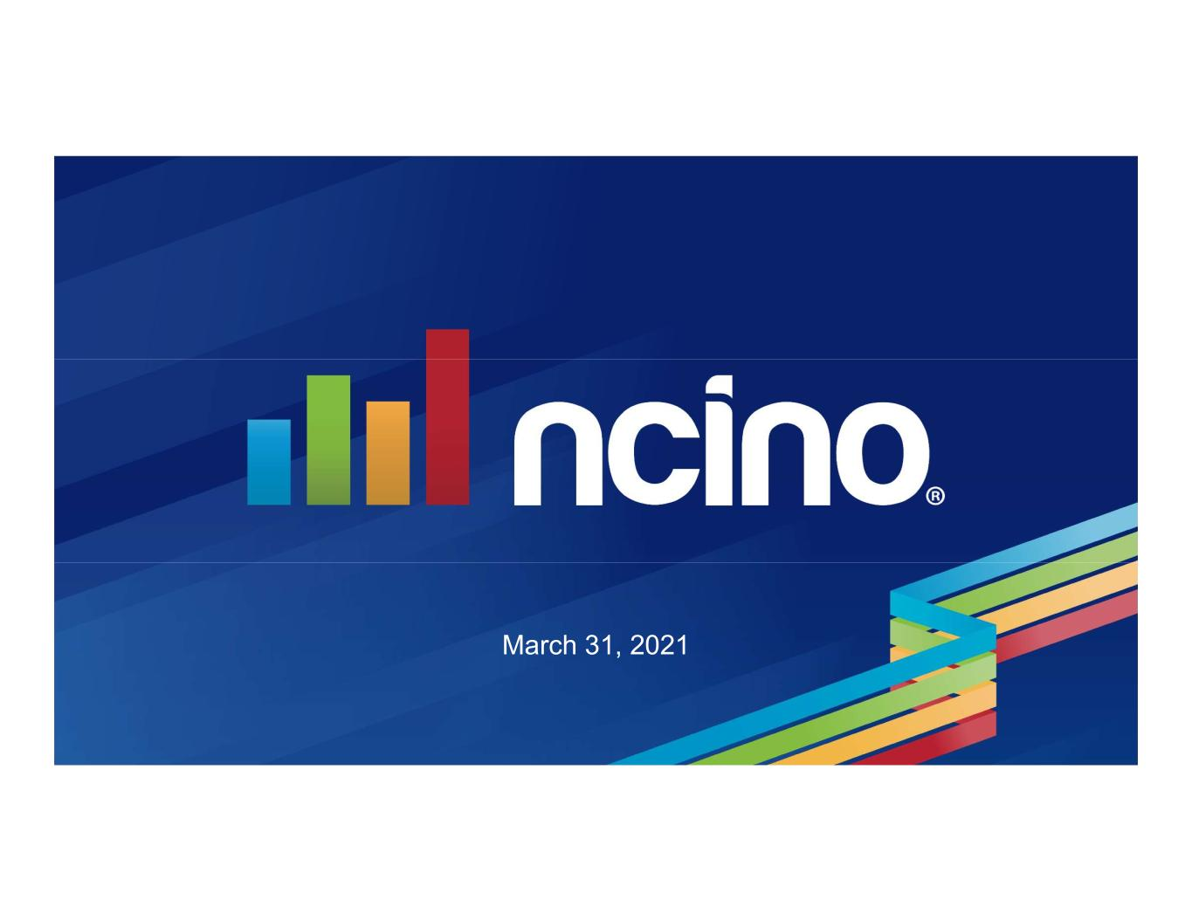

March 31, 2021

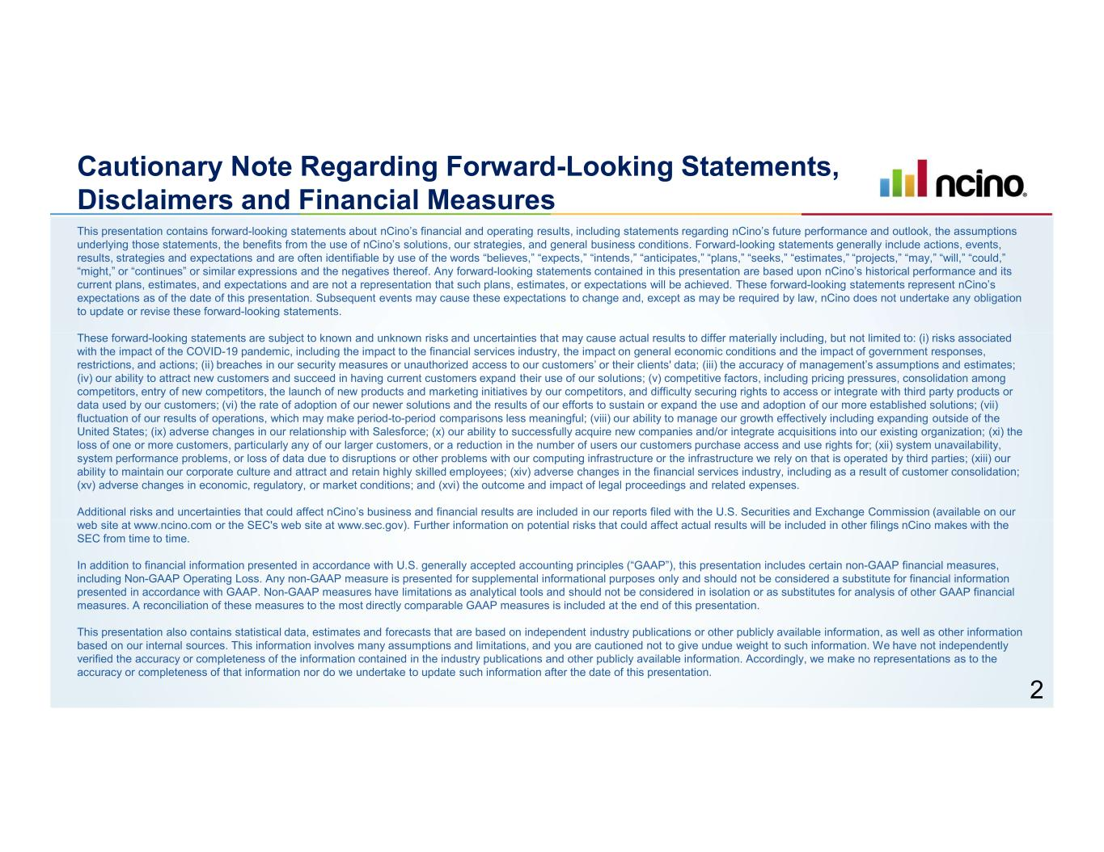
Cautionary Note Regarding Forward-Looking Statements, Disclaimers and Financial Measures This presentation contains forward-looking statements about nCino’s financial and operating results, including statements regarding nCino’s future performance and outlook, the assumptions underlying those statements, the benefits from the use of nCino’s solutions, our strategies, and general business conditions. Forward-looking statements generally include actions, events, results, strategies and expectations and are often identifiable by use of the words “believes,” “expects,” “intends,” “anticipates,” “plans,” “seeks,” “estimates,” “projects,” “may,” “will,” “could,” “might,” or “continues” or similar expressions and the negatives thereof. Any forward-looking statements contained in this presentation are based upon nCino’s historical performance and its current plans, estimates, and expectations and are not a representation that such plans, estimates, or expectations will be achieved. These forward-looking statements represent nCino’s expectations as of the date of this presentation. Subsequent events may cause these expectations to change and, except as may be required by law, nCino does not undertake any obligation to update or revise these forward-looking statements. These forward-looking statements are subject to known and unknown risks and uncertainties that may cause actual results to differ materially including, but not limited to: (i) risks associated with the impact of the COVID-19 pandemic, including the impact to the financial services industry, the impact on general economic conditions and the impact of government responses, restrictions, and actions; (ii) breaches in our security measures or unauthorized access to our customers’ or their clients' data; (iii) the accuracy of management’s assumptions and estimates; (iv) our ability to attract new customers and succeed in having current customers expand their use of our solutions; (v) competitive factors, including pricing pressures, consolidation among competitors, entry of new competitors, the launch of new products and marketing initiatives by our competitors, and difficulty securing rights to access or integrate with third party products or data used by our customers; (vi) the rate of adoption of our newer solutions and the results of our efforts to sustain or expand the use and adoption of our more established solutions; (vii) fluctuation of our results of operations, which may make period-to-period comparisons less meaningful; (viii) our ability to manage our growth effectively including expanding outside of the United States; (ix) adverse changes in our relationship with Salesforce; (x) our ability to successfully acquire new companies and/or integrate acquisitions into our existing organization; (xi) the loss of one or more customers, particularly any of our larger customers, or a reduction in the number of users our customers purchase access and use rights for; (xii) system unavailability, system performance problems, or loss of data due to disruptions or other problems with our computing infrastructure or the infrastructure we rely on that is operated by third parties; (xiii) our ability to maintain our corporate culture and attract and retain highly skilled employees; (xiv) adverse changes in the financial services industry, including as a result of customer consolidation; (xv) adverse changes in economic, regulatory, or market conditions; and (xvi) the outcome and impact of legal proceedings and related expenses. Additional risks and uncertainties that could affect nCino’s business and financial results are included in our reports filed with the U.S. Securities and Exchange Commission (available on our web site at www.ncino.com or the SEC's web site at www.sec.gov). Further information on potential risks that could affect actual results will be included in other filings nCino makes with the SEC from time to time. In addition to financial information presented in accordance with U.S. generally accepted accounting principles (“GAAP”), this presentation includes certain non-GAAP financial measures, including Non-GAAP Operating Loss. Any non-GAAP measure is presented for supplemental informational purposes only and should not be considered a substitute for financial information presented in accordance with GAAP. Non-GAAP measures have limitations as analytical tools and should not be considered in isolation or as substitutes for analysis of other GAAP financial measures. A reconciliation of these measures to the most directly comparable GAAP measures is included at the end of this presentation. This presentation also contains statistical data, estimates and forecasts that are based on independent industry publications or other publicly available information, as well as other information based on our internal sources. This information involves many assumptions and limitations, and you are cautioned not to give undue weight to such information. We have not independently verified the accuracy or completeness of the information contained in the industry publications and other publicly available information. Accordingly, we make no representations as to the accuracy or completeness of that information nor do we undertake to update such information after the date of this presentation. 2

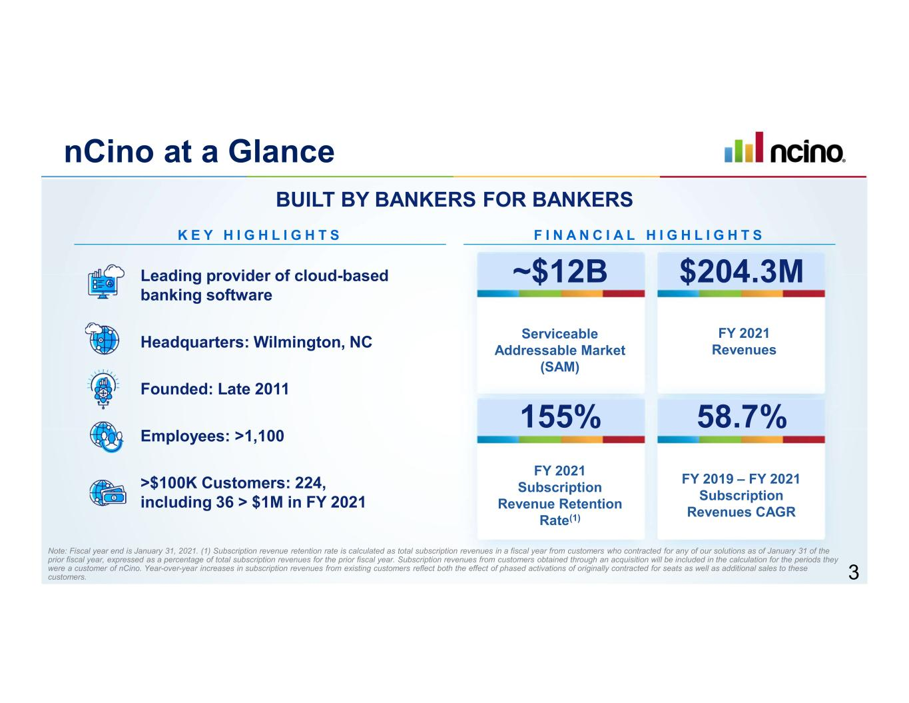
nCino at a Glance Leading provider of cloud-based banking software K E Y H I G H L I G H T S Headquarters: Wilmington, NC Founded: Late 2011 Employees: >1,100 >$100K Customers: 224, including 36 > $1M in FY 2021 F I N A N C I A L H I G H L I G H T S Serviceable Addressable Market (SAM) BUILT BY BANKERS FOR BANKERS ~$12B FY 2021 Revenues $204.3M FY 2021 Subscription Revenue Retention Rate(1) 155% FY 2019 – FY 2021 Subscription Revenues CAGR 58.7% Note: Fiscal year end is January 31, 2021. (1) Subscription revenue retention rate is calculated as total subscription revenues in a fiscal year from customers who contracted for any of our solutions as of January 31 of the prior fiscal year, expressed as a percentage of total subscription revenues for the prior fiscal year. Subscription revenues from customers obtained through an acquisition will be included in the calculation for the periods they were a customer of nCino. Year-over-year increases in subscription revenues from existing customers reflect both the effect of phased activations of originally contracted for seats as well as additional sales to these customers. 3

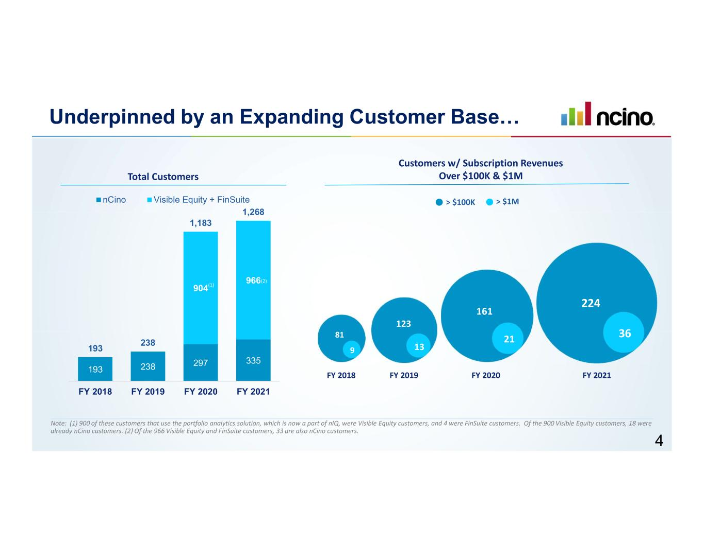
193 238 297 335 904 966 193 238 1,183 1,268 FY 2018 FY 2019 FY 2020 FY 2021 nCino Visible Equity + FinSuite Underpinned by an Expanding Customer Base… Total Customers Customers w/ Subscription Revenues Over $100K & $1M > $1M> $100K 81 9 FY 2018 123 13 FY 2019 161 21 FY 2020 Note: (1) 900 of these customers that use the portfolio analytics solution, which is now a part of nIQ, were Visible Equity customers, and 4 were FinSuite customers. Of the 900 Visible Equity customers, 18 were already nCino customers. (2) Of the 966 Visible Equity and FinSuite customers, 33 are also nCino customers. FY 2021 36 224 (1) (2) 4

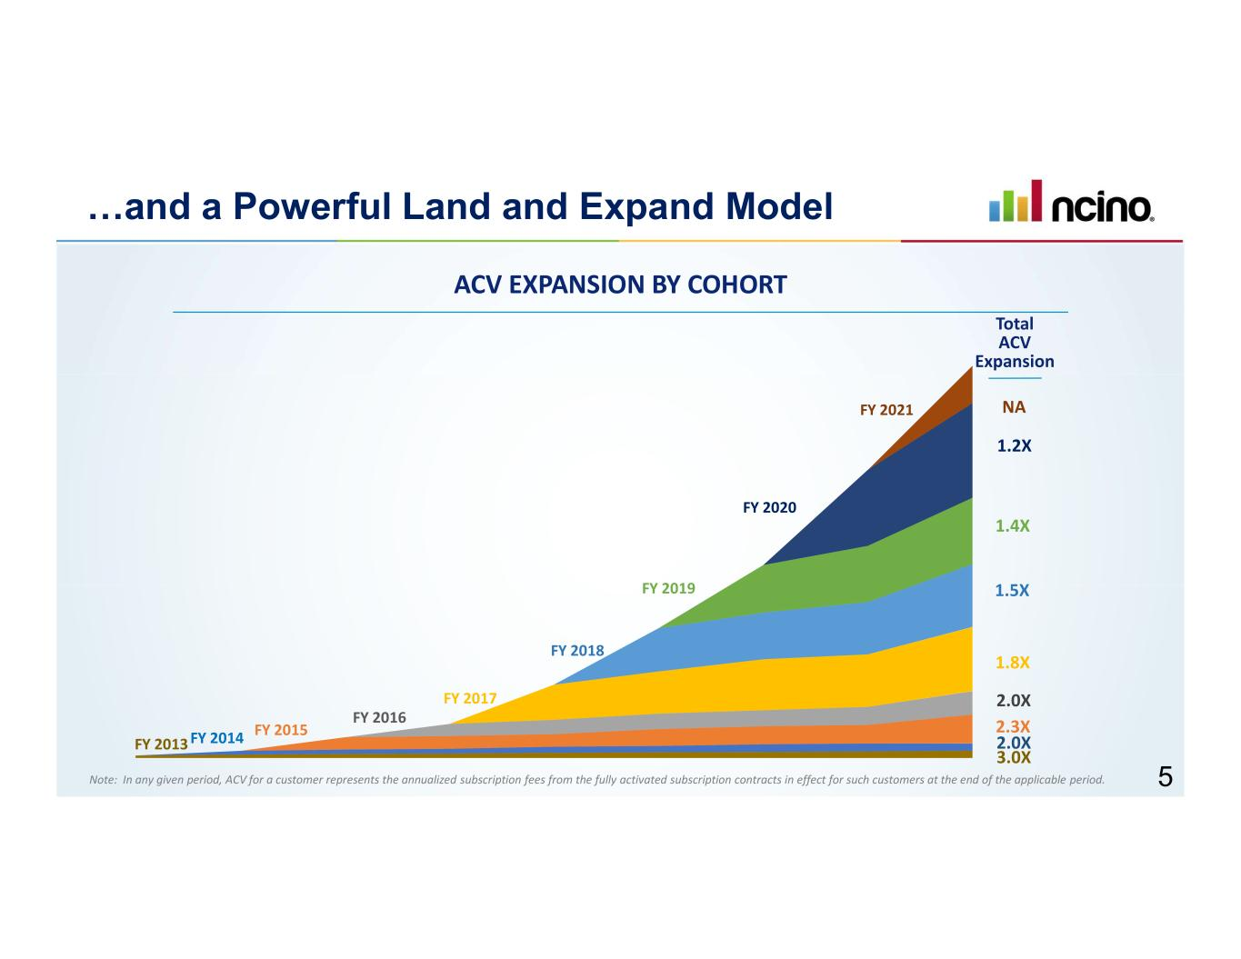
Total ACV Expansion FY 2013 FY 2014 FY 2015 FY 2016 FY 2017 FY 2018 FY 2019 FY 2020 FY 2021 3.0X 2.0X 2.3X 2.0X 1.8X 1.5X 1.4X 1.2X NA …and a Powerful Land and Expand Model ACV EXPANSION BY COHORT 5Note: In any given period, ACV for a customer represents the annualized subscription fees from the fully activated subscription contracts in effect for such customers at the end of the applicable period.

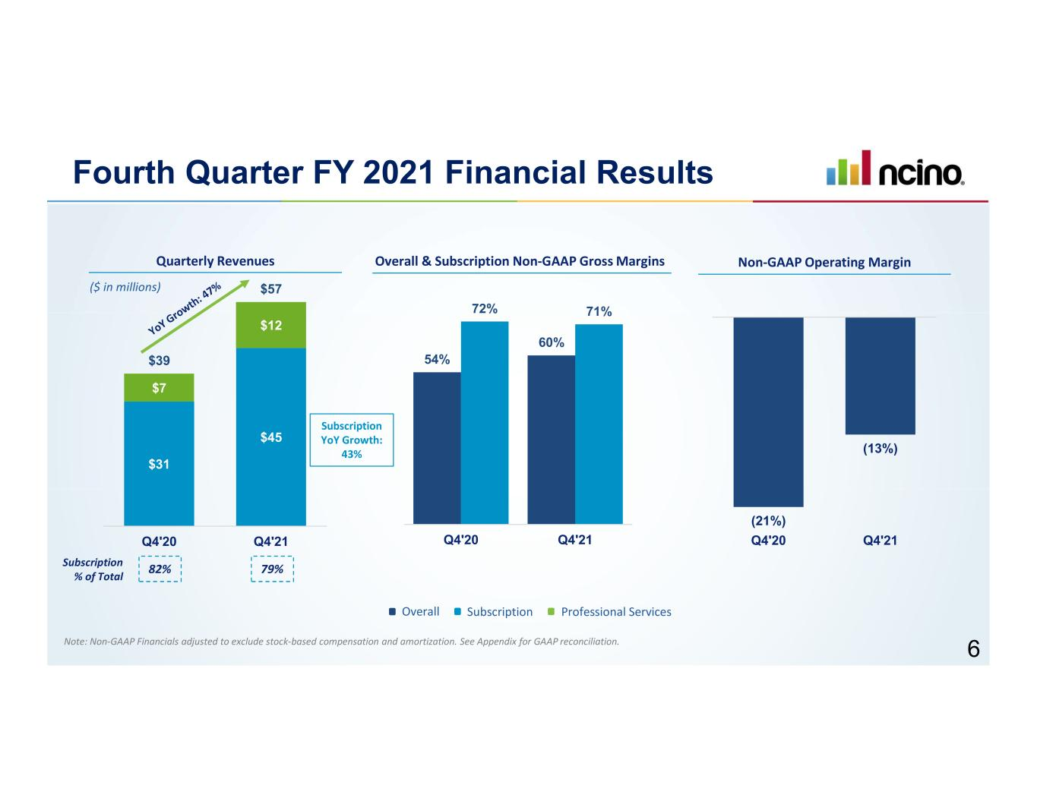
54% 60% 72% 71% Q4'20 Q4'21 Fourth Quarter FY 2021 Financial Results Quarterly Revenues ($ in millions) $31 $45 $7 $12 $39 $57 Q4'20 Q4'21 Subscription % of Total 79%82% Non-GAAP Operating Margin (21%) (13%) Q4'20 Q4'21 Overall & Subscription Non-GAAP Gross Margins Overall Subscription Professional Services Subscription YoY Growth: 43% Note: Non-GAAP Financials adjusted to exclude stock-based compensation and amortization. See Appendix for GAAP reconciliation. 6

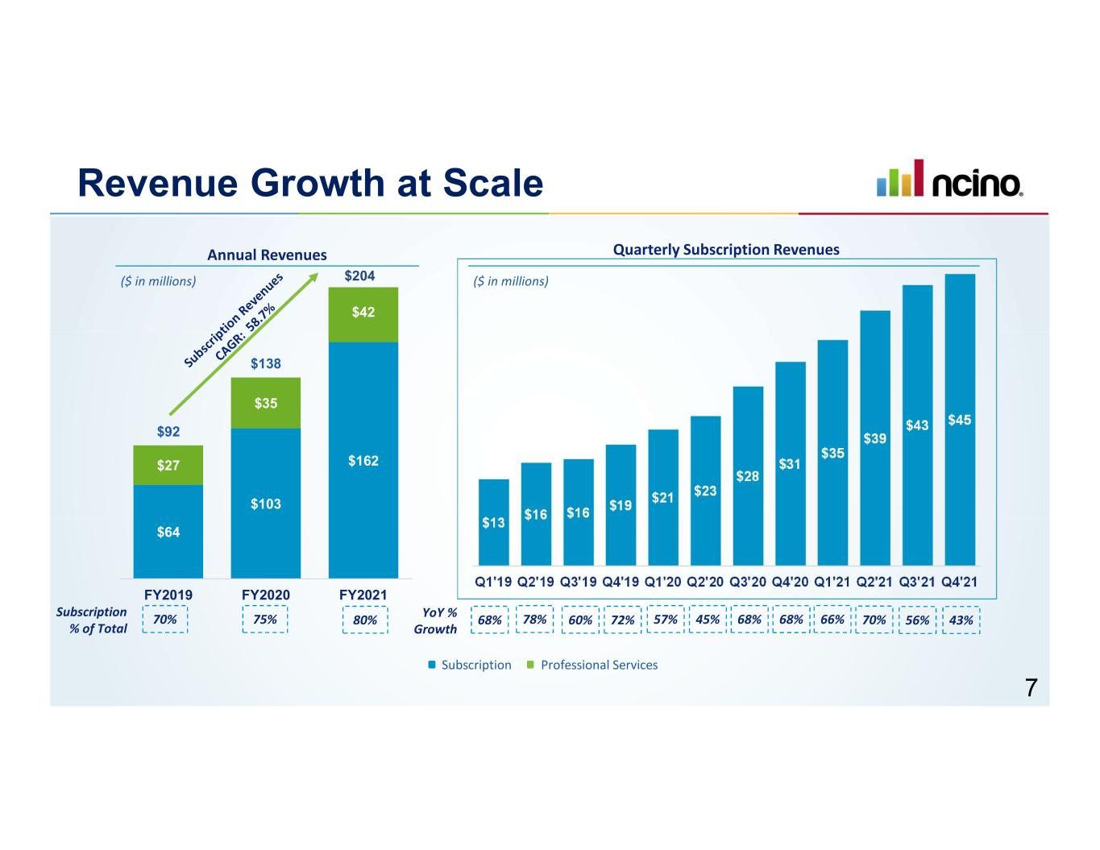
$64 $103 $162 $27 $35 $42 $92 $138 FY2019 FY2020 FY2021 $13 $16 $16 $19 $21 $23 $28 $31 $35 $39 $43 $45 Q1'19 Q2'19 Q3'19 Q4'19 Q1'20 Q2'20 Q3'20 Q4'20 Q1'21 Q2'21 Q3'21 Q4'21 Revenue Growth at Scale Annual Revenues ($ in millions) Quarterly Subscription Revenues ($ in millions) Subscription Professional Services Subscription % of Total 70% 75% YoY % Growth 68% 78% 60% 72% 57% 45% 68% 68% 66%80% 70% 56% 43% $204 7

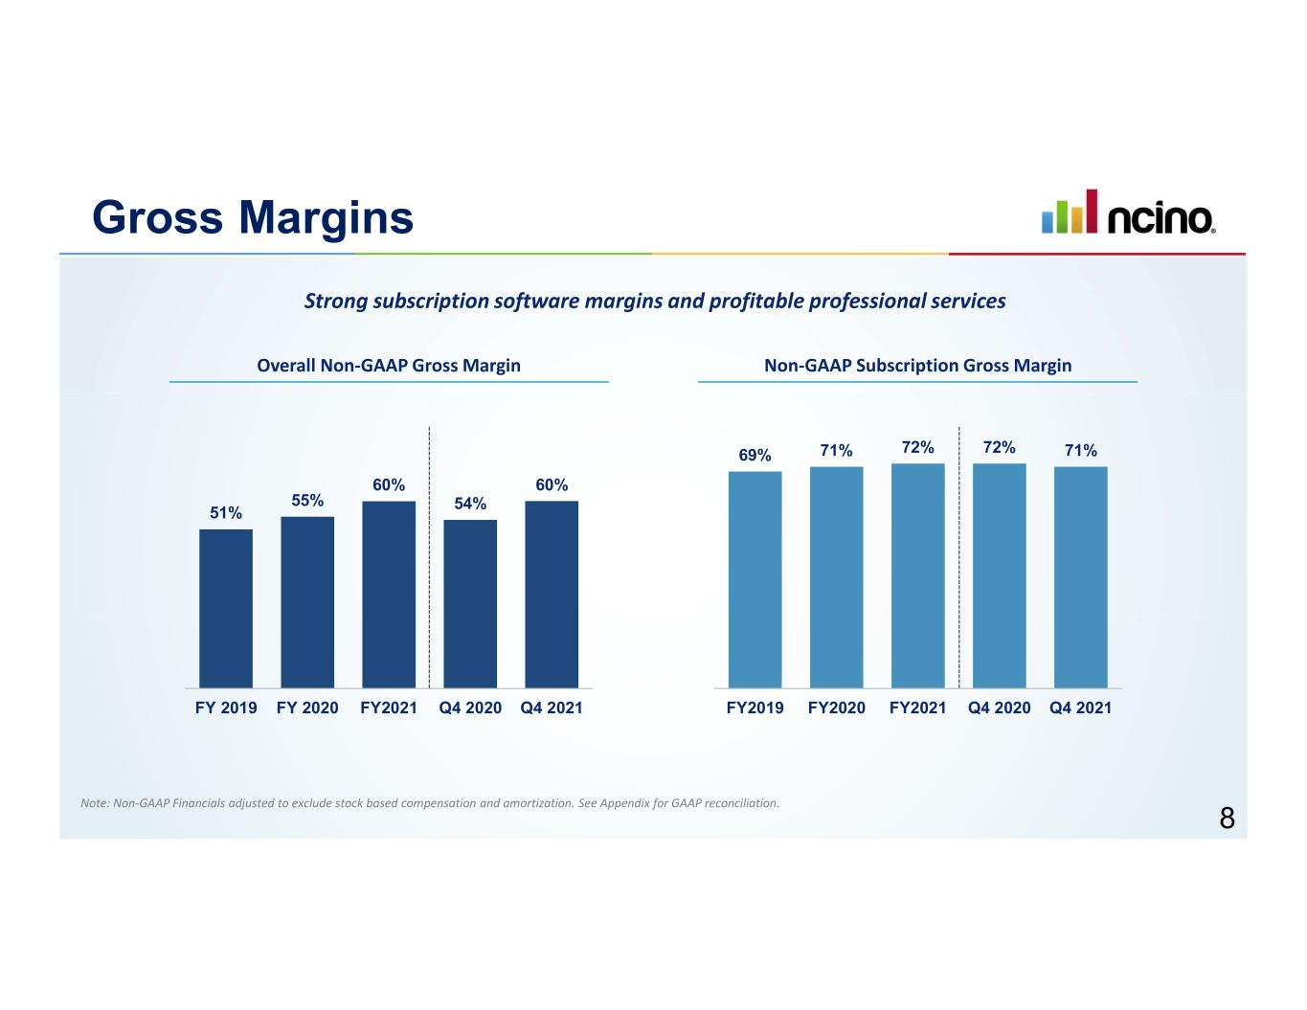
Gross Margins Overall Non-GAAP Gross Margin Non-GAAP Subscription Gross Margin Note: Non-GAAP Financials adjusted to exclude stock based compensation and amortization. See Appendix for GAAP reconciliation. 51% 55% 60% 54% 60% FY 2019 FY 2020 FY2021 Q4 2020 Q4 2021 69% 71% 72% 72% 71% FY2019 FY2020 FY2021 Q4 2020 Q4 2021 Strong subscription software margins and profitable professional services 8

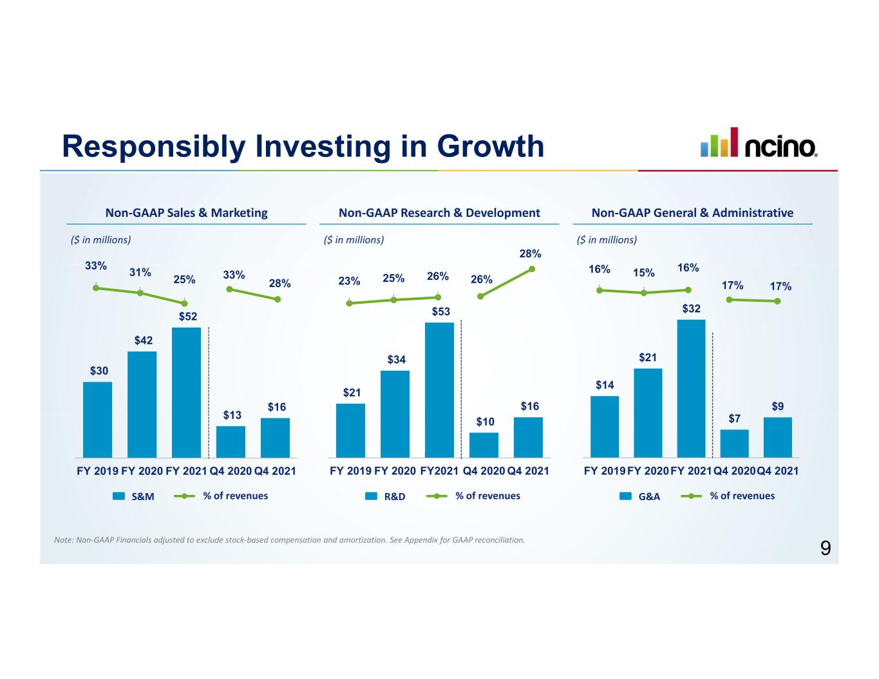
$14 $21 $32 $7 $9 FY 2019FY 2020FY 2021Q4 2020Q4 2021 $21 $34 $53 $10 $16 FY 2019 FY 2020 FY2021 Q4 2020 Q4 2021 $30 $42 $52 $13 $16 FY 2019 FY 2020 FY 2021 Q4 2020 Q4 2021 Responsibly Investing in Growth Note: Non-GAAP Financials adjusted to exclude stock-based compensation and amortization. See Appendix for GAAP reconciliation. 16% 15% 16% 23% 25% 26% 33% 31% 25% ($ in millions)($ in millions) ($ in millions) 33% 28% 26% 28% 17% 17% S&M % of revenues R&D % of revenues G&A % of revenues Non-GAAP General & AdministrativeNon-GAAP Sales & Marketing Non-GAAP Research & Development 9

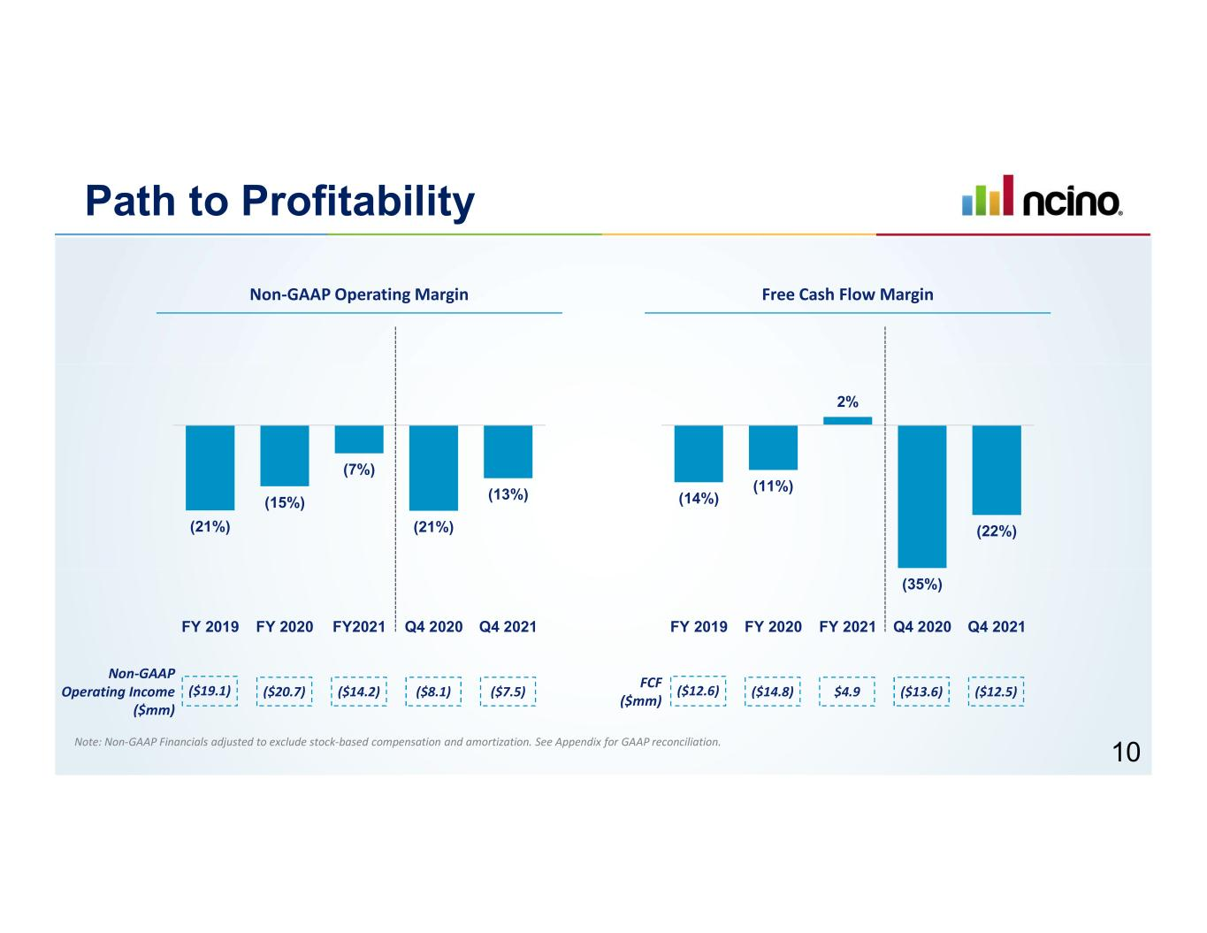
Path to Profitability Free Cash Flow Margin (14%) (11%) 2% (35%) (22%) FY 2019 FY 2020 FY 2021 Q4 2020 Q4 2021 (21%) (15%) (7%) (21%) (13%) FY 2019 FY 2020 FY2021 Q4 2020 Q4 2021 Non-GAAP Operating Margin ($19.1) ($20.7) Non-GAAP Operating Income ($mm) ($14.2) ($12.6) ($14.8) FCF ($mm) $4.9($8.1) ($7.5) ($13.6) ($12.5) 10 Note: Non-GAAP Financials adjusted to exclude stock-based compensation and amortization. See Appendix for GAAP reconciliation.

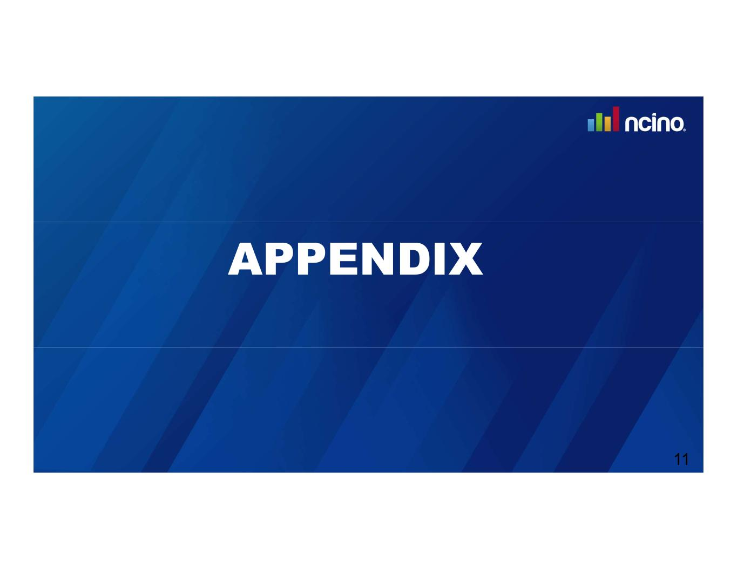
APPENDIX 11

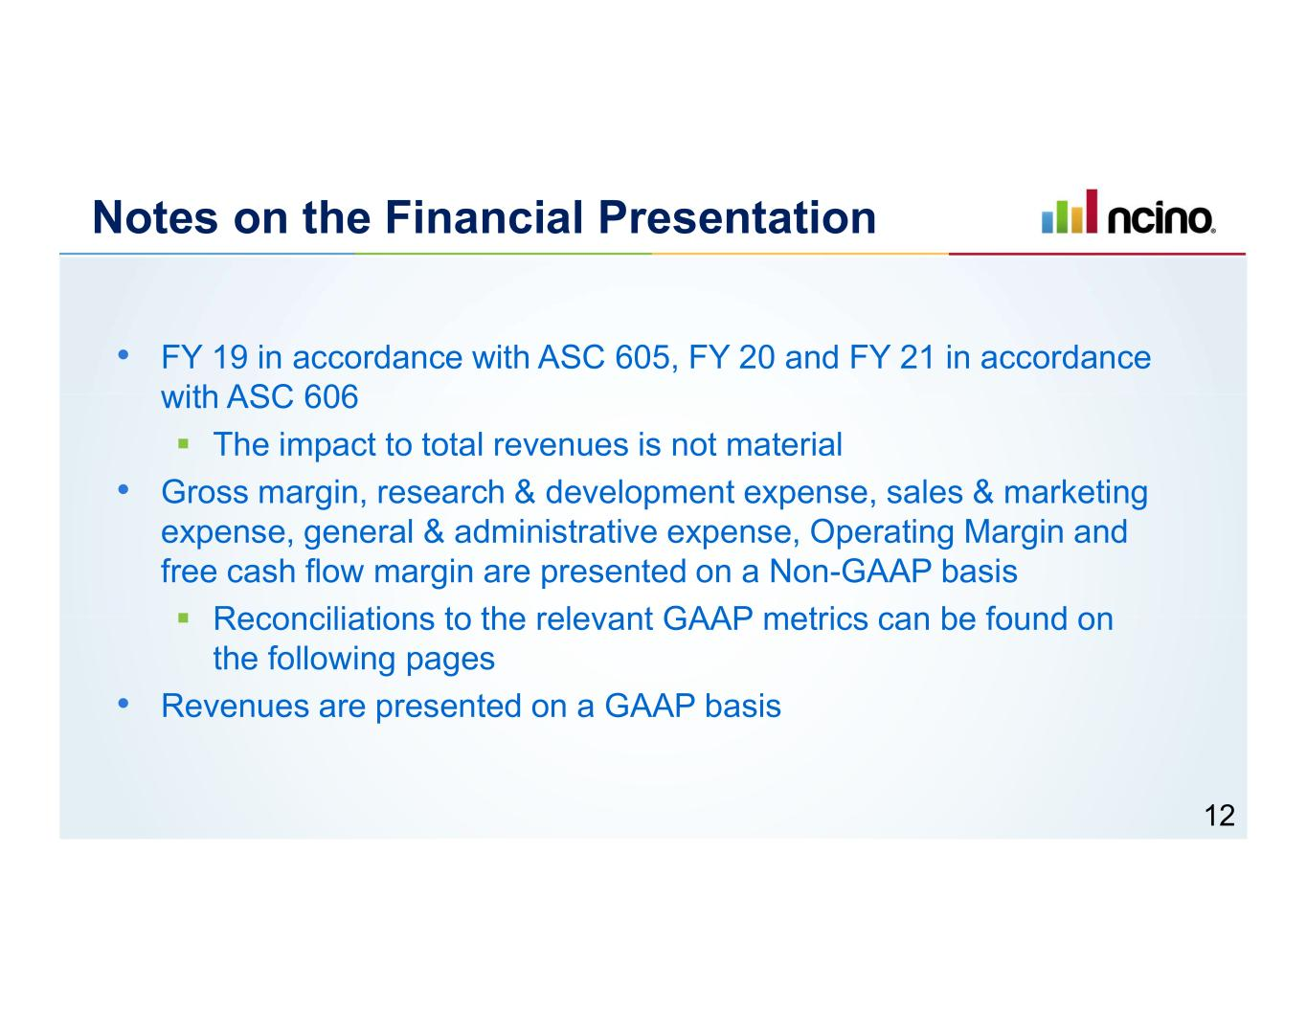
Notes on the Financial Presentation • FY 19 in accordance with ASC 605, FY 20 and FY 21 in accordance with ASC 606 ▪ The impact to total revenues is not material • Gross margin, research & development expense, sales & marketing expense, general & administrative expense, Operating Margin and free cash flow margin are presented on a Non-GAAP basis ▪ Reconciliations to the relevant GAAP metrics can be found on the following pages • Revenues are presented on a GAAP basis 12

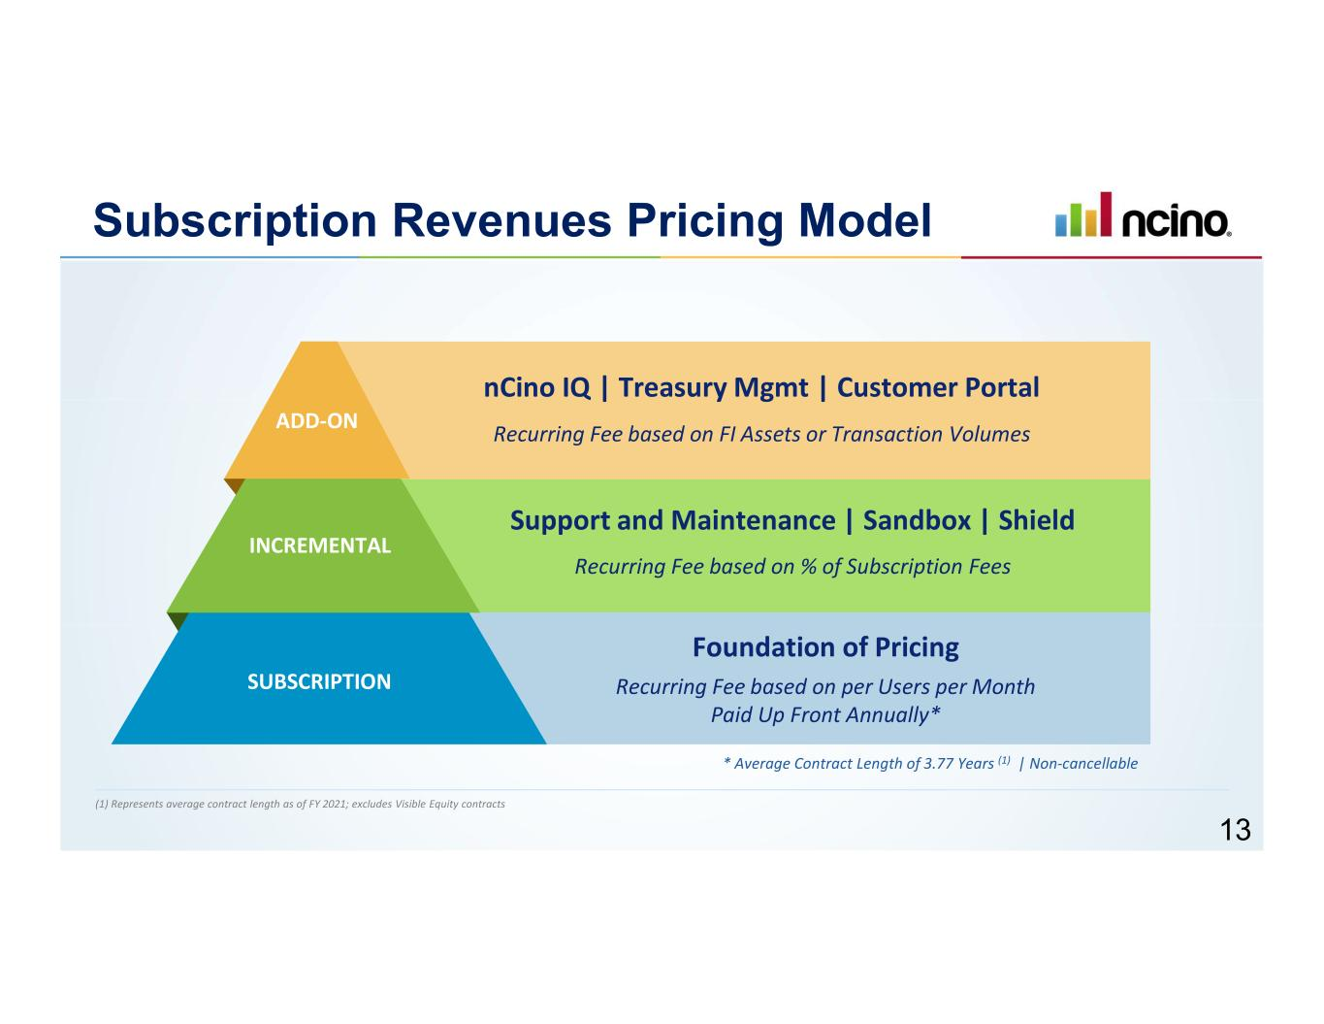
Subscription Revenues Pricing Model Recurring Fee based on FI Assets or Transaction Volumes Recurring Fee based on % of Subscription Fees Recurring Fee based on per Users per Month Paid Up Front Annually* SUBSCRIPTION INCREMENTAL ADD-ON Foundation of Pricing Support and Maintenance | Sandbox | Shield nCino IQ | Treasury Mgmt | Customer Portal * Average Contract Length of 3.77 Years (1) | Non-cancellable (1) Represents average contract length as of FY 2021; excludes Visible Equity contracts 13

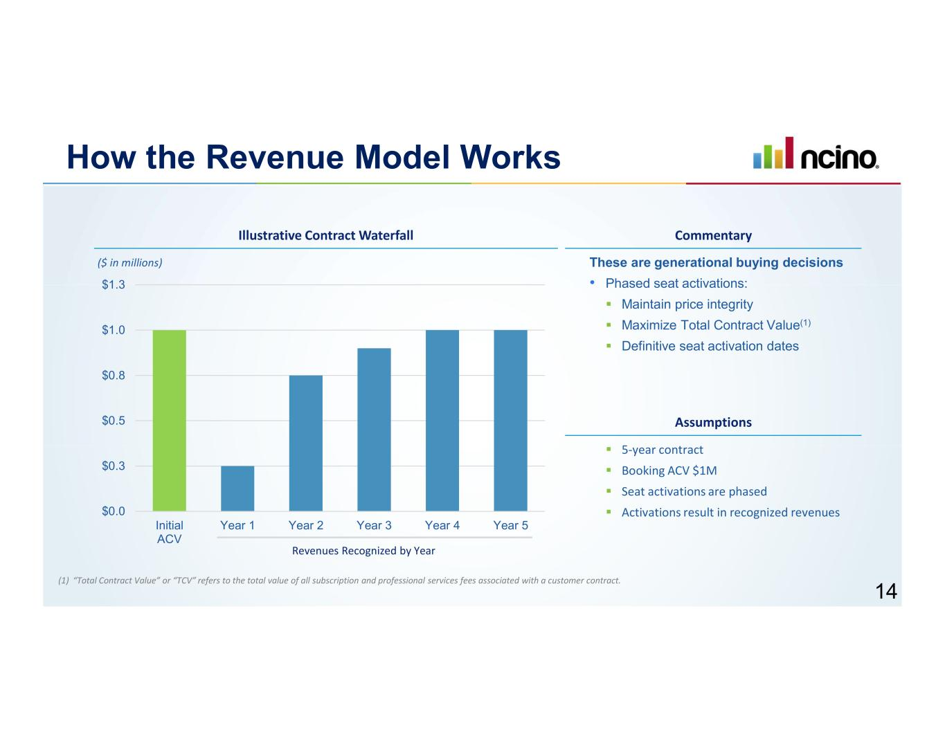
How the Revenue Model Works These are generational buying decisions • Phased seat activations: ▪ Maintain price integrity ▪ Maximize Total Contract Value(1) ▪ Definitive seat activation dates $0.0 $0.3 $0.5 $0.8 $1.0 $1.3 Initial ACV Year 1 Year 2 Year 3 Year 4 Year 5 Revenues Recognized by Year ▪ 5-year contract ▪ Booking ACV $1M ▪ Seat activations are phased ▪ Activations result in recognized revenues Illustrative Contract Waterfall Commentary ($ in millions) Assumptions (1) “Total Contract Value” or “TCV” refers to the total value of all subscription and professional services fees associated with a customer contract. 14

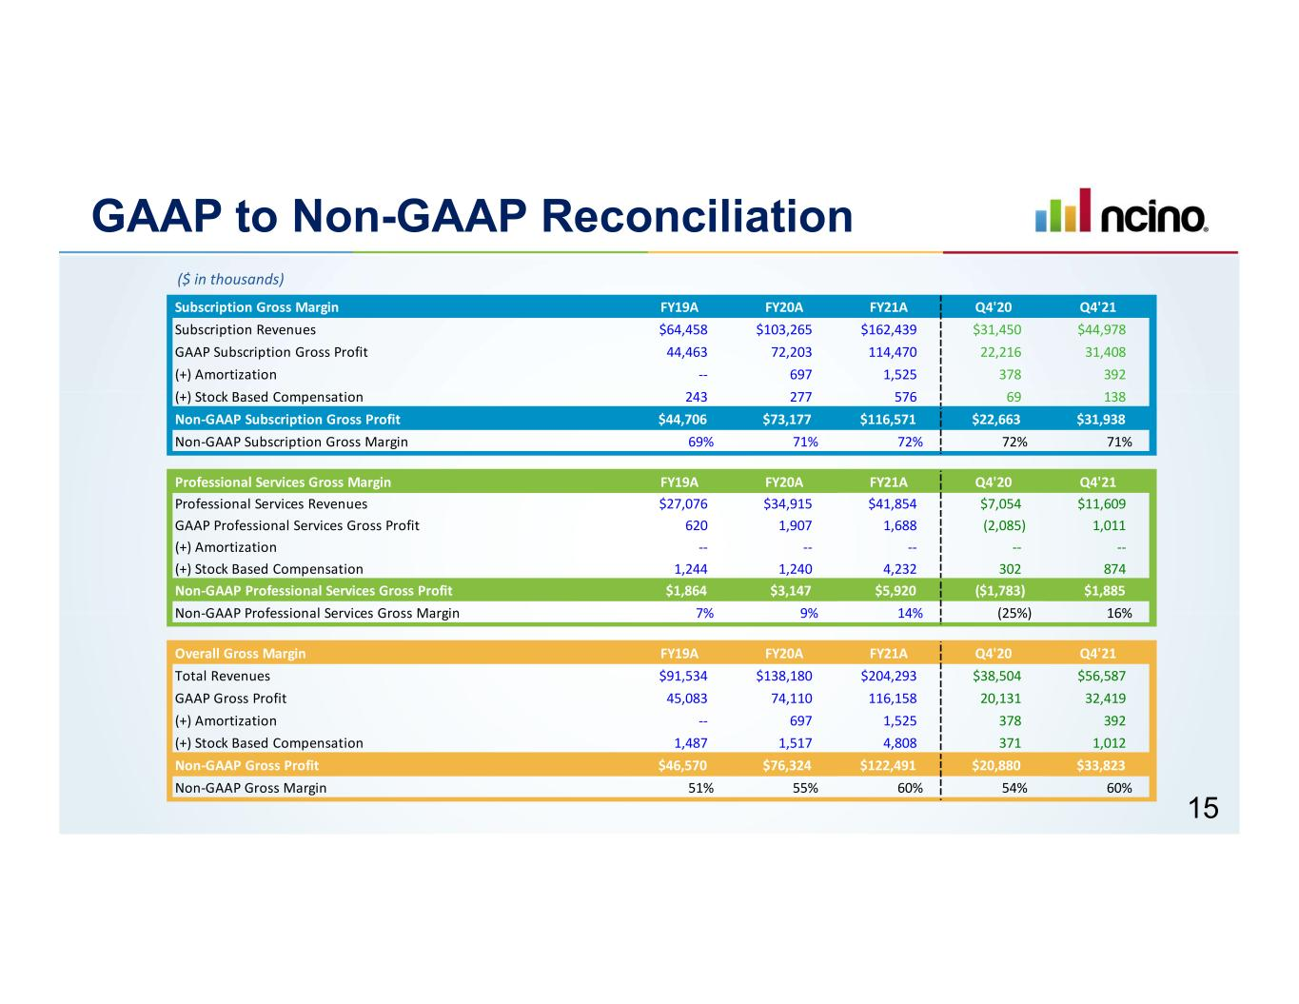
GAAP to Non-GAAP Reconciliation ($ in thousands) 15 Subscription Gross Margin FY19A FY20A FY21A Q4'20 Q4'21 Subscription Revenues $64,458 $103,265 $162,439 $31,450 $44,978 GAAP Subscription Gross Profit 44,463 72,203 114,470 22,216 31,408 (+) Amortization -- 697 1,525 378 392 (+) Stock Based Compensation 243 277 576 69 138 Non-GAAP Subscription Gross Profit $44,706 $73,177 $116,571 $22,663 $31,938 Non-GAAP Subscription Gross Margin 69% 71% 72% 72% 71% Professional Services Gross Margin FY19A FY20A FY21A Q4'20 Q4'21 Professional Services Revenues $27,076 $34,915 $41,854 $7,054 $11,609 GAAP Professional Services Gross Profit 620 1,907 1,688 (2,085) 1,011 (+) Amortization -- -- -- -- -- (+) Stock Based Compensation 1,244 1,240 4,232 302 874 Non-GAAP Professional Services Gross Profit $1,864 $3,147 $5,920 ($1,783) $1,885 Non-GAAP Professional Services Gross Margin 7% 9% 14% (25%) 16% Overall Gross Margin FY19A FY20A FY21A Q4'20 Q4'21 Total Revenues $91,534 $138,180 $204,293 $38,504 $56,587 GAAP Gross Profit 45,083 74,110 116,158 20,131 32,419 (+) Amortization -- 697 1,525 378 392 (+) Stock Based Compensation 1,487 1,517 4,808 371 1,012 Non-GAAP Gross Profit $46,570 $76,324 $122,491 $20,880 $33,823 Non-GAAP Gross Margin 51% 55% 60% 54% 60%

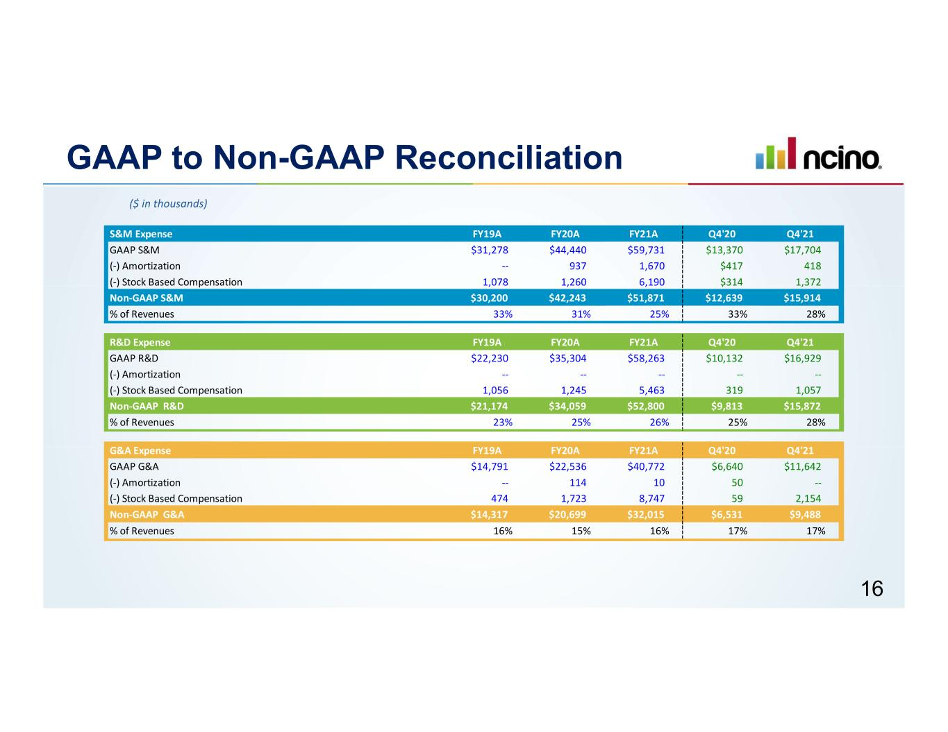
GAAP to Non-GAAP Reconciliation ($ in thousands) 16 S&M Expense FY19A FY20A FY21A Q4'20 Q4'21 GAAP S&M $31,278 $44,440 $59,731 $13,370 $17,704 (-) Amortization -- 937 1,670 $417 418 (-) Stock Based Compensation 1,078 1,260 6,190 $314 1,372 Non-GAAP S&M $30,200 $42,243 $51,871 $12,639 $15,914 % of Revenues 33% 31% 25% 33% 28% R&D Expense FY19A FY20A FY21A Q4'20 Q4'21 GAAP R&D $22,230 $35,304 $58,263 $10,132 $16,929 (-) Amortization -- -- -- -- -- (-) Stock Based Compensation 1,056 1,245 5,463 319 1,057 Non-GAAP R&D $21,174 $34,059 $52,800 $9,813 $15,872 % of Revenues 23% 25% 26% 25% 28% G&A Expense FY19A FY20A FY21A Q4'20 Q4'21 GAAP G&A $14,791 $22,536 $40,772 $6,640 $11,642 (-) Amortization -- 114 10 50 -- (-) Stock Based Compensation 474 1,723 8,747 59 2,154 Non-GAAP G&A $14,317 $20,699 $32,015 $6,531 $9,488 % of Revenues 16% 15% 16% 17% 17%

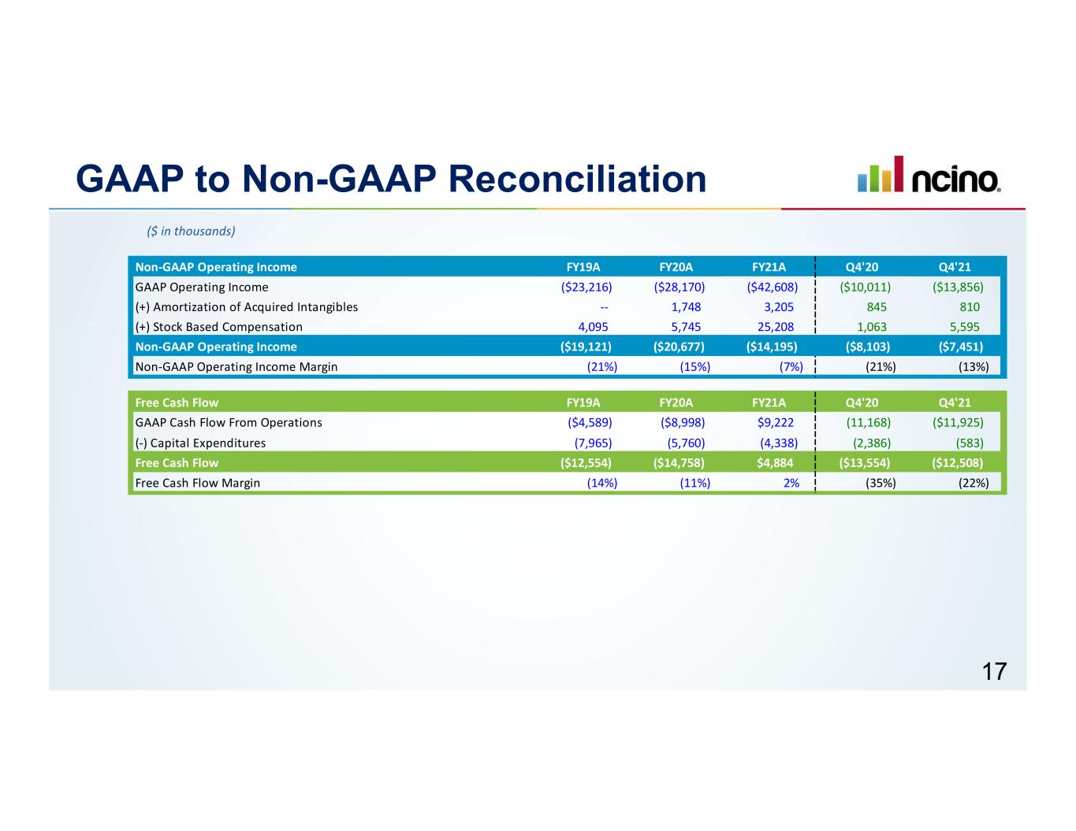
GAAP to Non-GAAP Reconciliation ($ in thousands) 17 Non-GAAP Operating Income FY19A FY20A FY21A Q4'20 Q4'21 GAAP Operating Income ($23,216) ($28,170) ($42,608) ($10,011) ($13,856) (+) Amortization of Acquired Intangibles -- 1,748 3,205 845 810 (+) Stock Based Compensation 4,095 5,745 25,208 1,063 5,595 Non-GAAP Operating Income ($19,121) ($20,677) ($14,195) ($8,103) ($7,451) Non-GAAP Operating Income Margin (21%) (15%) (7%) (21%) (13%) Free Cash Flow FY19A FY20A FY21A Q4'20 Q4'21 GAAP Cash Flow From Operations ($4,589) ($8,998) $9,222 (11,168) ($11,925) (-) Capital Expenditures (7,965) (5,760) (4,338) (2,386) (583) Free Cash Flow ($12,554) ($14,758) $4,884 ($13,554) ($12,508) Free Cash Flow Margin (14%) (11%) 2% (35%) (22%)

March 31, 2021

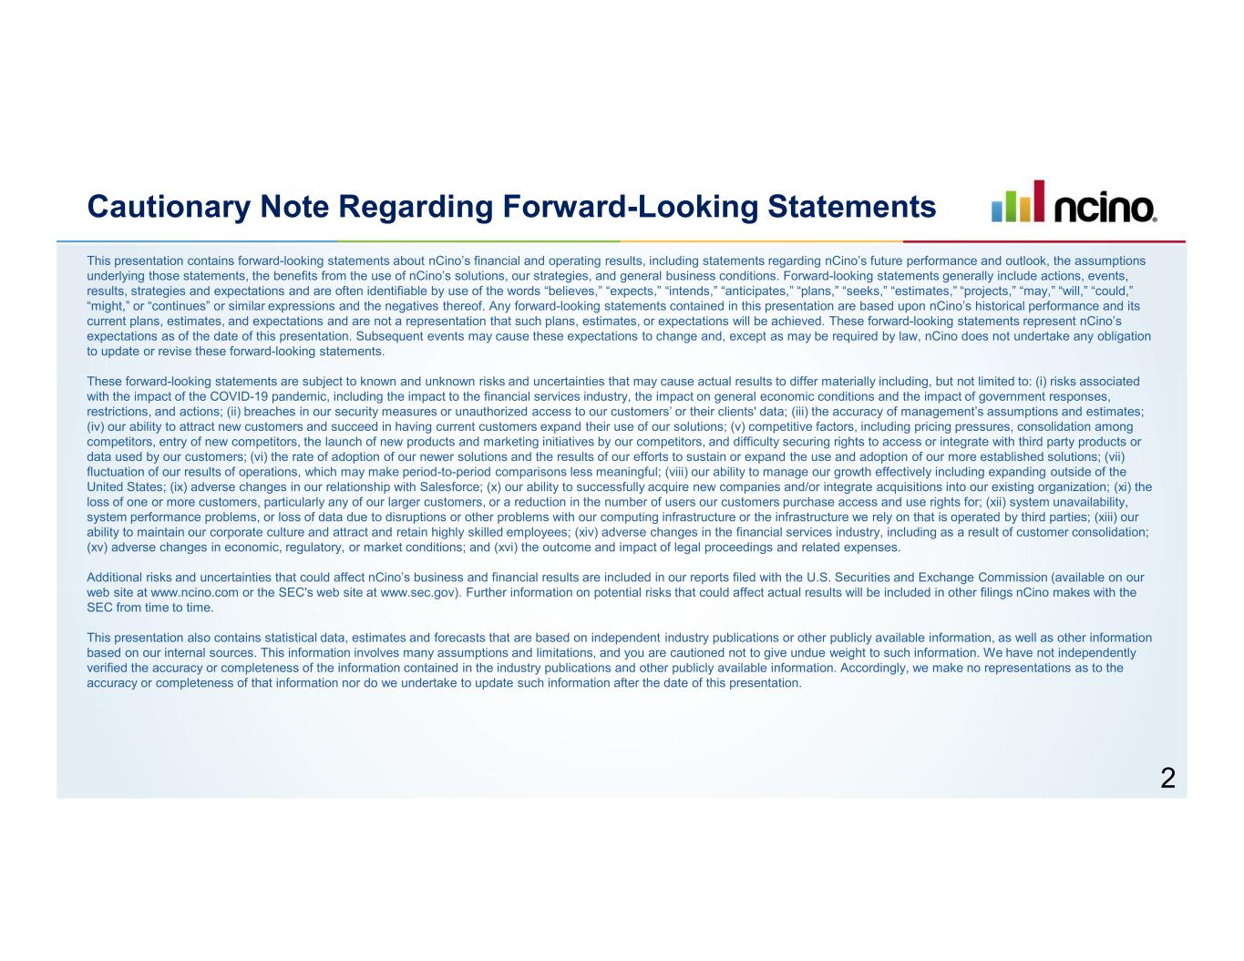
Cautionary Note Regarding Forward-Looking Statements This presentation contains forward-looking statements about nCino’s financial and operating results, including statements regarding nCino’s future performance and outlook, the assumptions underlying those statements, the benefits from the use of nCino’s solutions, our strategies, and general business conditions. Forward-looking statements generally include actions, events, results, strategies and expectations and are often identifiable by use of the words “believes,” “expects,” “intends,” “anticipates,” “plans,” “seeks,” “estimates,” “projects,” “may,” “will,” “could,” “might,” or “continues” or similar expressions and the negatives thereof. Any forward-looking statements contained in this presentation are based upon nCino’s historical performance and its current plans, estimates, and expectations and are not a representation that such plans, estimates, or expectations will be achieved. These forward-looking statements represent nCino’s expectations as of the date of this presentation. Subsequent events may cause these expectations to change and, except as may be required by law, nCino does not undertake any obligation to update or revise these forward-looking statements. These forward-looking statements are subject to known and unknown risks and uncertainties that may cause actual results to differ materially including, but not limited to: (i) risks associated with the impact of the COVID-19 pandemic, including the impact to the financial services industry, the impact on general economic conditions and the impact of government responses, restrictions, and actions; (ii) breaches in our security measures or unauthorized access to our customers’ or their clients' data; (iii) the accuracy of management’s assumptions and estimates; (iv) our ability to attract new customers and succeed in having current customers expand their use of our solutions; (v) competitive factors, including pricing pressures, consolidation among competitors, entry of new competitors, the launch of new products and marketing initiatives by our competitors, and difficulty securing rights to access or integrate with third party products or data used by our customers; (vi) the rate of adoption of our newer solutions and the results of our efforts to sustain or expand the use and adoption of our more established solutions; (vii) fluctuation of our results of operations, which may make period-to-period comparisons less meaningful; (viii) our ability to manage our growth effectively including expanding outside of the United States; (ix) adverse changes in our relationship with Salesforce; (x) our ability to successfully acquire new companies and/or integrate acquisitions into our existing organization; (xi) the loss of one or more customers, particularly any of our larger customers, or a reduction in the number of users our customers purchase access and use rights for; (xii) system unavailability, system performance problems, or loss of data due to disruptions or other problems with our computing infrastructure or the infrastructure we rely on that is operated by third parties; (xiii) our ability to maintain our corporate culture and attract and retain highly skilled employees; (xiv) adverse changes in the financial services industry, including as a result of customer consolidation; (xv) adverse changes in economic, regulatory, or market conditions; and (xvi) the outcome and impact of legal proceedings and related expenses. Additional risks and uncertainties that could affect nCino’s business and financial results are included in our reports filed with the U.S. Securities and Exchange Commission (available on our web site at www.ncino.com or the SEC's web site at www.sec.gov). Further information on potential risks that could affect actual results will be included in other filings nCino makes with the SEC from time to time. This presentation also contains statistical data, estimates and forecasts that are based on independent industry publications or other publicly available information, as well as other information based on our internal sources. This information involves many assumptions and limitations, and you are cautioned not to give undue weight to such information. We have not independently verified the accuracy or completeness of the information contained in the industry publications and other publicly available information. Accordingly, we make no representations as to the accuracy or completeness of that information nor do we undertake to update such information after the date of this presentation. 2

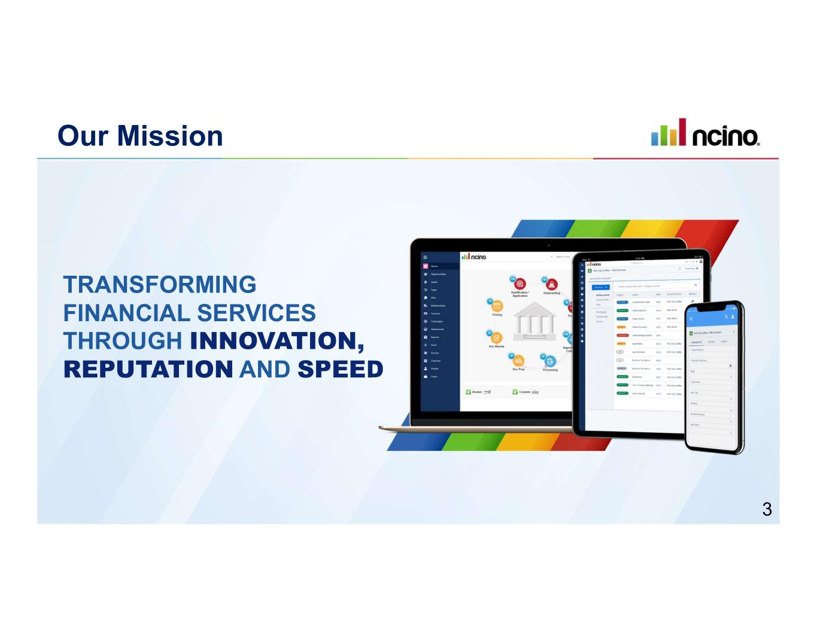
TRANSFORMING FINANCIAL SERVICES THROUGH INNOVATION, REPUTATION AND SPEED Our Mission 3

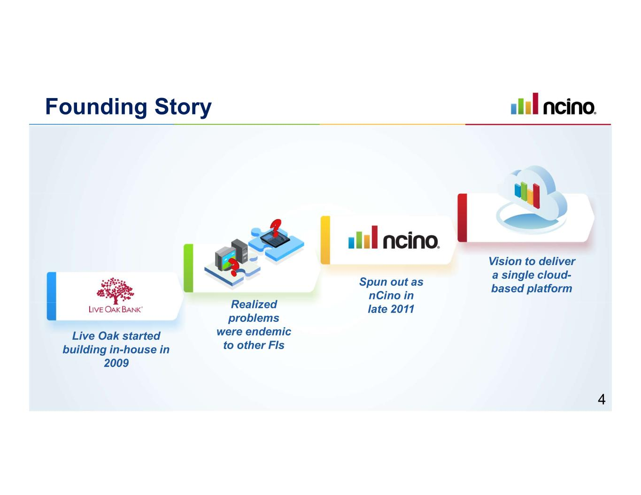
Founding Story Live Oak started building in-house in 2009 Realized problems were endemic to other FIs Spun out as nCino in late 2011 Vision to deliver a single cloud- based platform 4

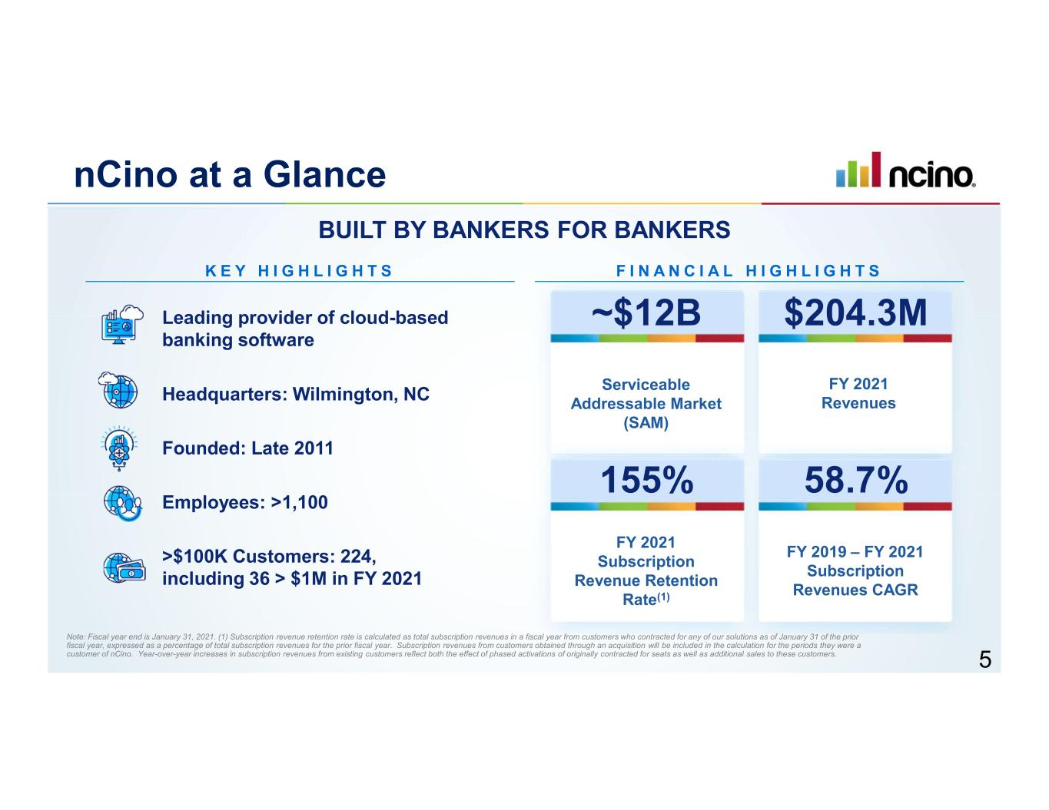
nCino at a Glance Leading provider of cloud-based banking software K E Y H I G H L I G H T S Headquarters: Wilmington, NC Founded: Late 2011 Employees: >1,100 >$100K Customers: 224, including 36 > $1M in FY 2021 F I N A N C I A L H I G H L I G H T S Serviceable Addressable Market (SAM) BUILT BY BANKERS FOR BANKERS ~$12B FY 2021 Revenues $204.3M FY 2021 Subscription Revenue Retention Rate(1) 155% FY 2019 – FY 2021 Subscription Revenues CAGR 58.7% Note: Fiscal year end is January 31, 2021. (1) Subscription revenue retention rate is calculated as total subscription revenues in a fiscal year from customers who contracted for any of our solutions as of January 31 of the prior fiscal year, expressed as a percentage of total subscription revenues for the prior fiscal year. Subscription revenues from customers obtained through an acquisition will be included in the calculation for the periods they were a customer of nCino. Year-over-year increases in subscription revenues from existing customers reflect both the effect of phased activations of originally contracted for seats as well as additional sales to these customers. 5

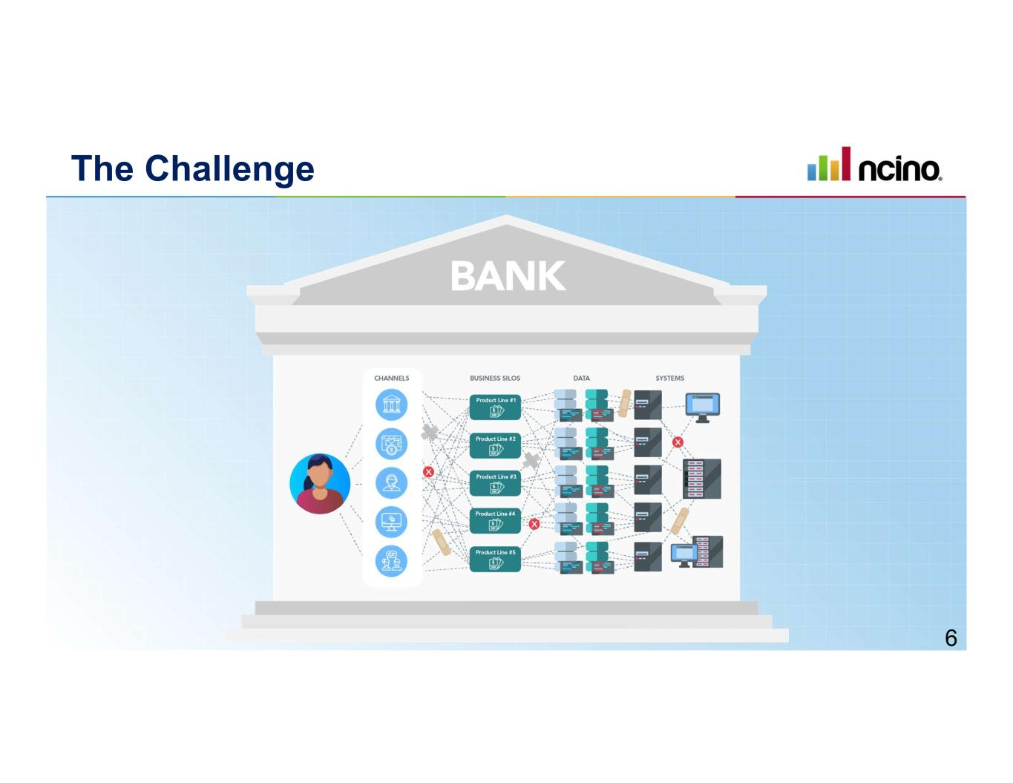
The Challenge 6

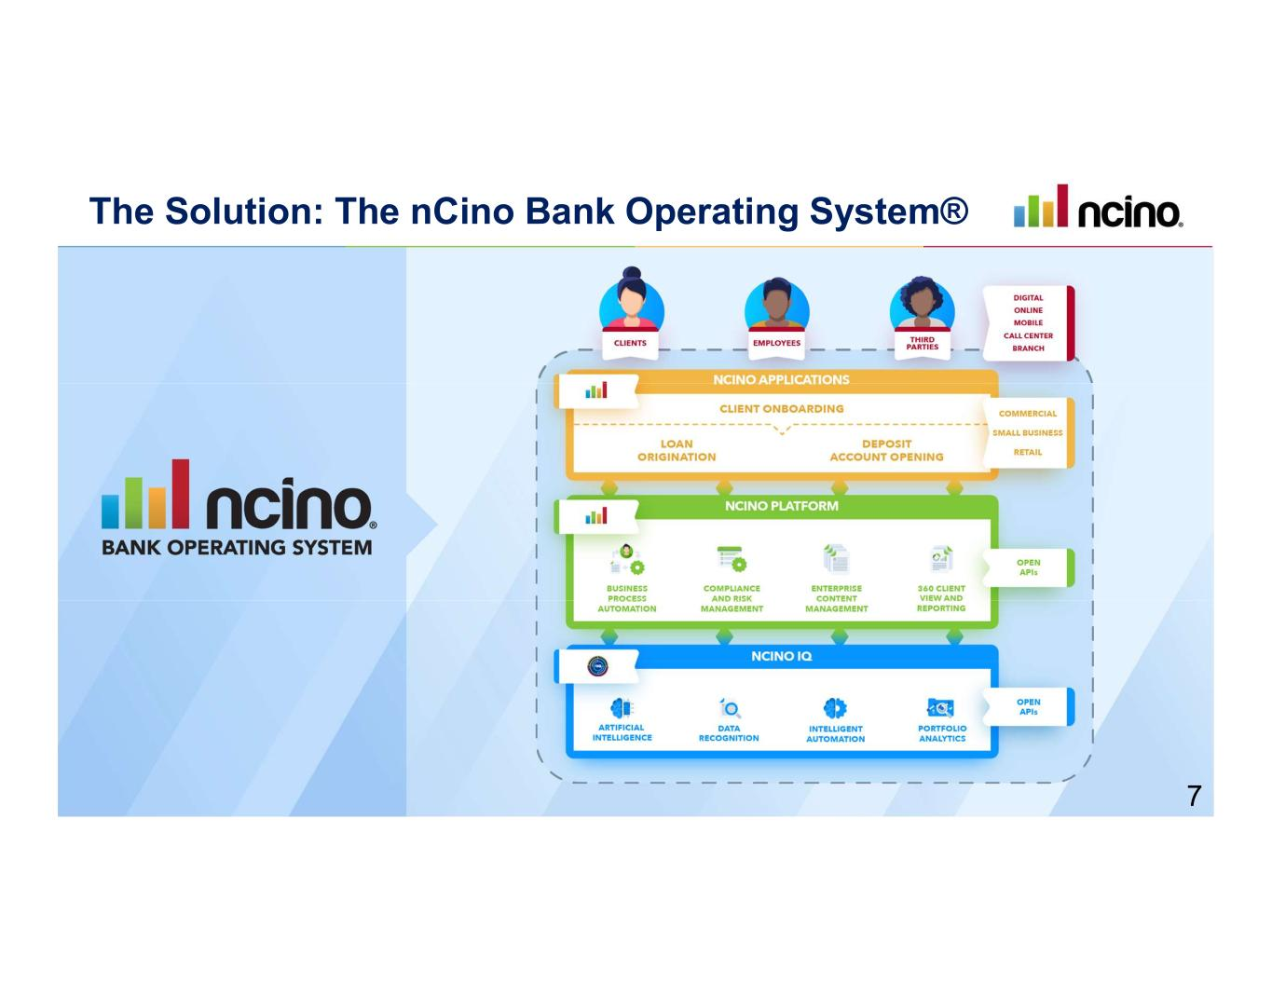
The Solution: The nCino Bank Operating System® 7

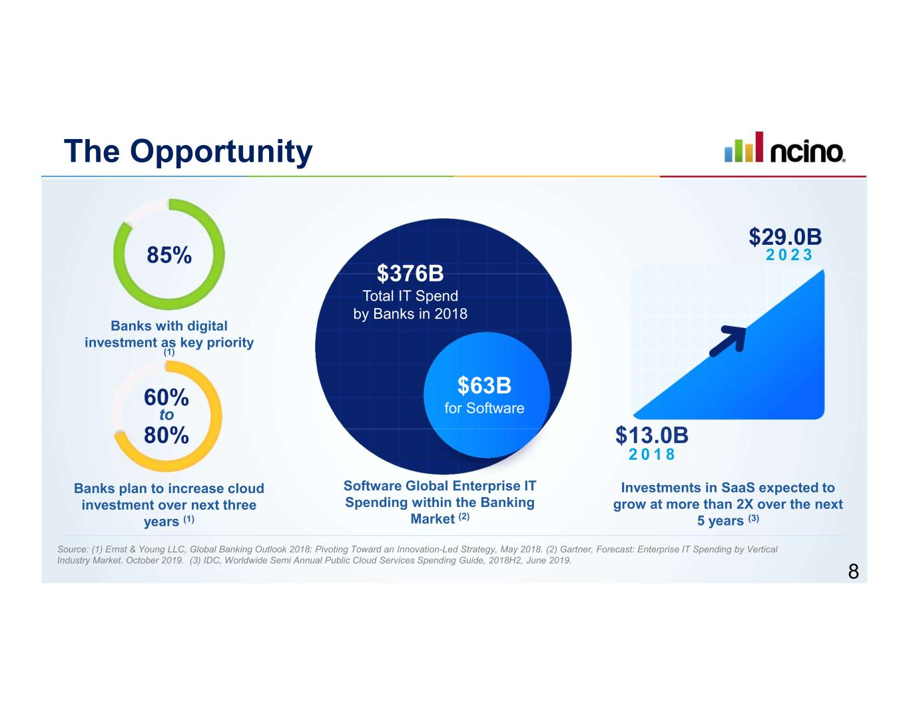
The Opportunity 2 0 1 8 Investments in SaaS expected to grow at more than 2X over the next 5 years (3) $13.0B $29.0B 2 0 2 385% 60% to Banks with digital investment as key priority (1) Banks plan to increase cloud investment over next three years (1) $63B for Software $376B Total IT Spend by Banks in 2018 Software Global Enterprise IT Spending within the Banking Market (2) 80% Source: (1) Ernst & Young LLC, Global Banking Outlook 2018: Pivoting Toward an Innovation-Led Strategy, May 2018. (2) Gartner, Forecast: Enterprise IT Spending by Vertical Industry Market. October 2019. (3) IDC, Worldwide Semi Annual Public Cloud Services Spending Guide, 2018H2, June 2019. 8

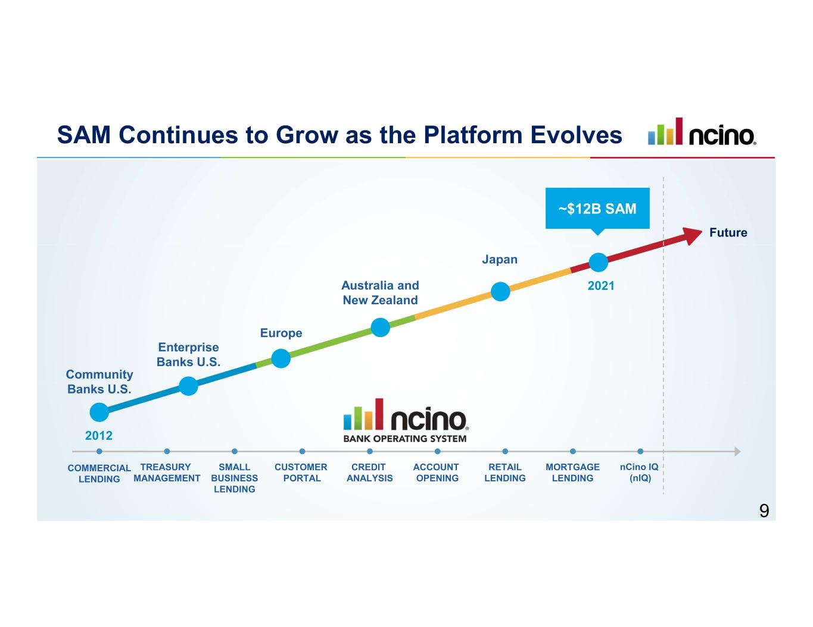
SAM Continues to Grow as the Platform Evolves CUSTOMER PORTAL ACCOUNT OPENING COMMERCIAL LENDING SMALL BUSINESS LENDING CREDIT ANALYSIS RETAIL LENDING MORTGAGE LENDING TREASURY MANAGEMENT Community Banks U.S. Enterprise Banks U.S. Europe Australia and New Zealand Japan 2012 2021 nCino IQ (nIQ) Future ~$12B SAM 9

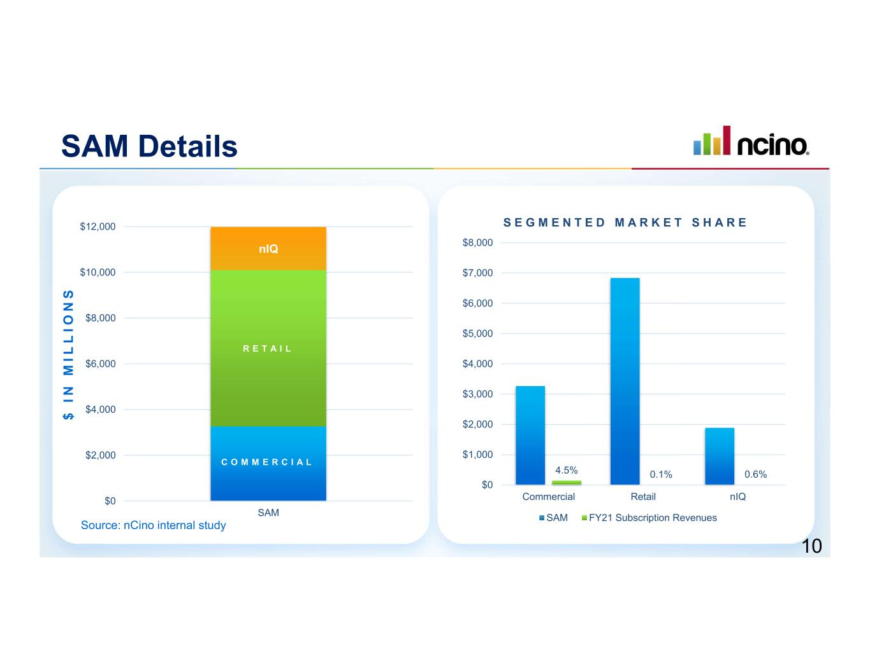
SAM Details C O M M E R C I A L R E T A I L nIQ $0 $2,000 $4,000 $6,000 $8,000 $10,000 $12,000 SAM 4.5% 0.1% 0.6% $0 $1,000 $2,000 $3,000 $4,000 $5,000 $6,000 $7,000 $8,000 Commercial Retail nIQ S E G M E N T E D M A R K E T S H A R E SAM FY21 Subscription Revenues $ I N M I L L I O N S Source: nCino internal study 10

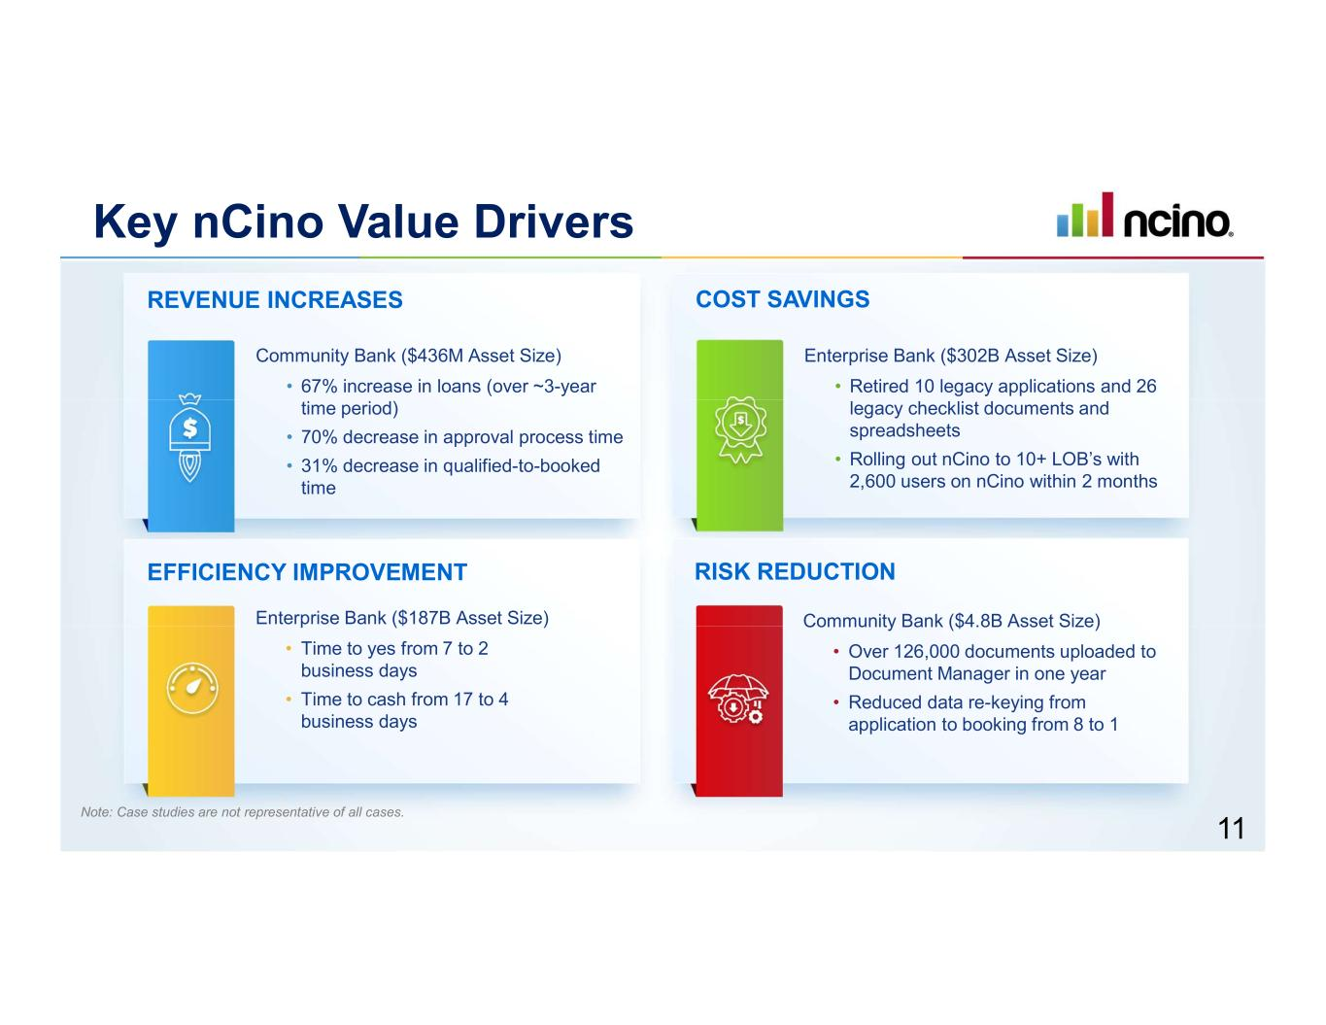
REVENUE INCREASES RISK REDUCTION Community Bank ($436M Asset Size) • 67% increase in loans (over ~3-year time period) • 70% decrease in approval process time • 31% decrease in qualified-to-booked time EFFICIENCY IMPROVEMENT Enterprise Bank ($187B Asset Size) • Time to yes from 7 to 2 business days • Time to cash from 17 to 4 business days COST SAVINGS Enterprise Bank ($302B Asset Size) • Retired 10 legacy applications and 26 legacy checklist documents and spreadsheets • Rolling out nCino to 10+ LOB’s with 2,600 users on nCino within 2 months Community Bank ($4.8B Asset Size) • Over 126,000 documents uploaded to Document Manager in one year • Reduced data re-keying from application to booking from 8 to 1 Key nCino Value Drivers Note: Case studies are not representative of all cases. 11

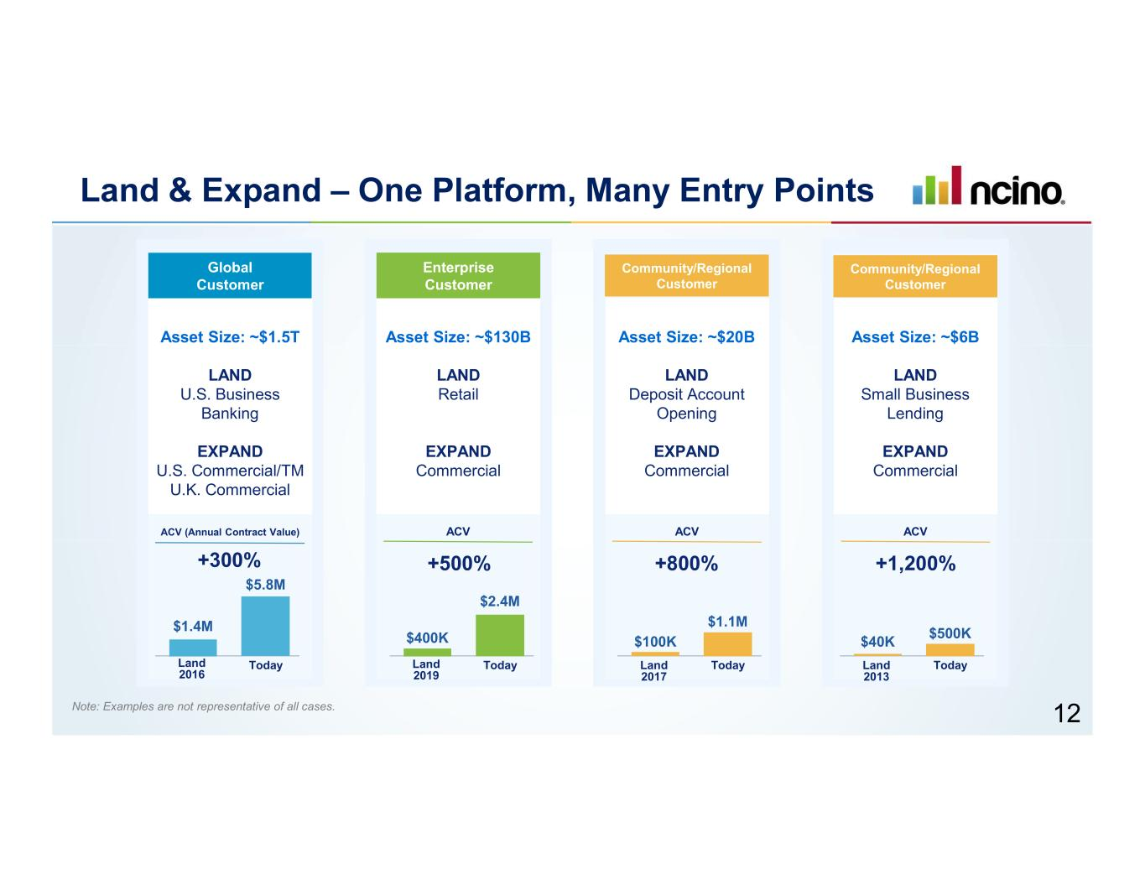
Land & Expand – One Platform, Many Entry Points Note: Examples are not representative of all cases. +300% $1.4M $5.8M Land 2016 Today Global Customer ACV (Annual Contract Value) Asset Size: ~$1.5T LAND U.S. Business Banking EXPAND U.S. Commercial/TM U.K. Commercial Enterprise Customer ACV Asset Size: ~$130B LAND Retail EXPAND Commercial +500% $400K $2.4M Land 2019 Today Community/Regional Customer ACV Asset Size: ~$20B LAND Deposit Account Opening EXPAND Commercial +800% $100K $1.1M Land 2017 Today Community/Regional Customer ACV Asset Size: ~$6B LAND Small Business Lending EXPAND Commercial +1,200% $40K $500K Land 2013 Today 12

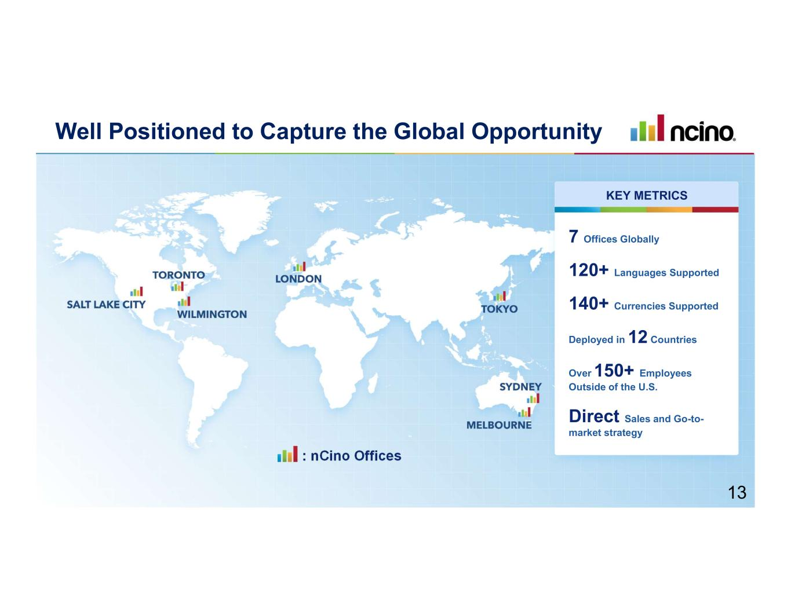
: nCino Offices 7 Offices Globally 120+ Languages Supported 140+ Currencies Supported Deployed in 12 Countries Over 150+ Employees Outside of the U.S. Direct Sales and Go-to- market strategy KEY METRICS Well Positioned to Capture the Global Opportunity 13

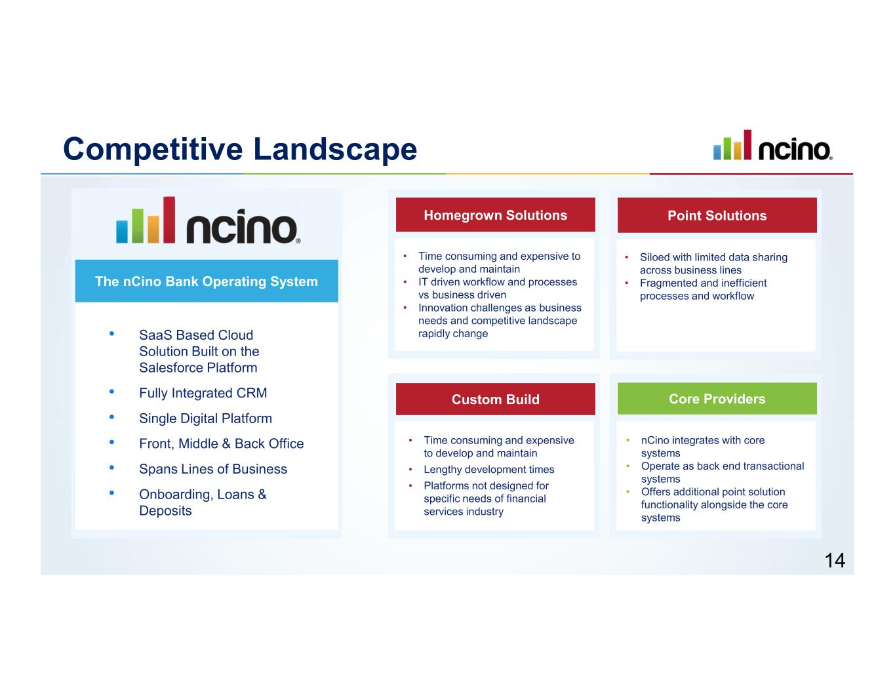
The nCino Bank Operating System • SaaS Based Cloud Solution Built on the Salesforce Platform • Fully Integrated CRM • Single Digital Platform • Front, Middle & Back Office • Spans Lines of Business • Onboarding, Loans & Deposits Homegrown Solutions • Time consuming and expensive to develop and maintain • IT driven workflow and processes vs business driven • Innovation challenges as business needs and competitive landscape rapidly change Custom Build • Time consuming and expensive to develop and maintain • Lengthy development times • Platforms not designed for specific needs of financial services industry Point Solutions • Siloed with limited data sharing across business lines • Fragmented and inefficient processes and workflow Core Providers • nCino integrates with core systems • Operate as back end transactional systems • Offers additional point solution functionality alongside the core systems Competitive Landscape 14

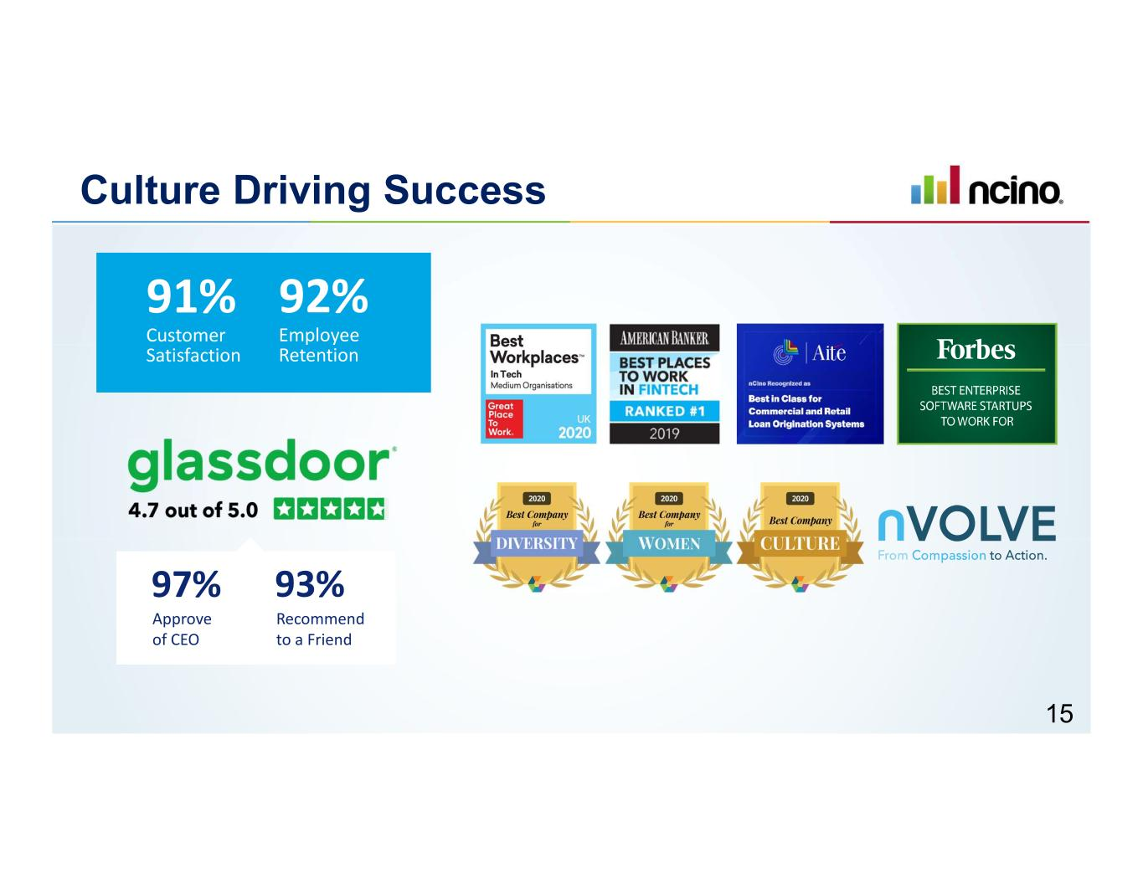
Culture Driving Success 91% Customer Satisfaction 92% Employee Retention Recommend to a Friend 93% Approve of CEO 97% 15

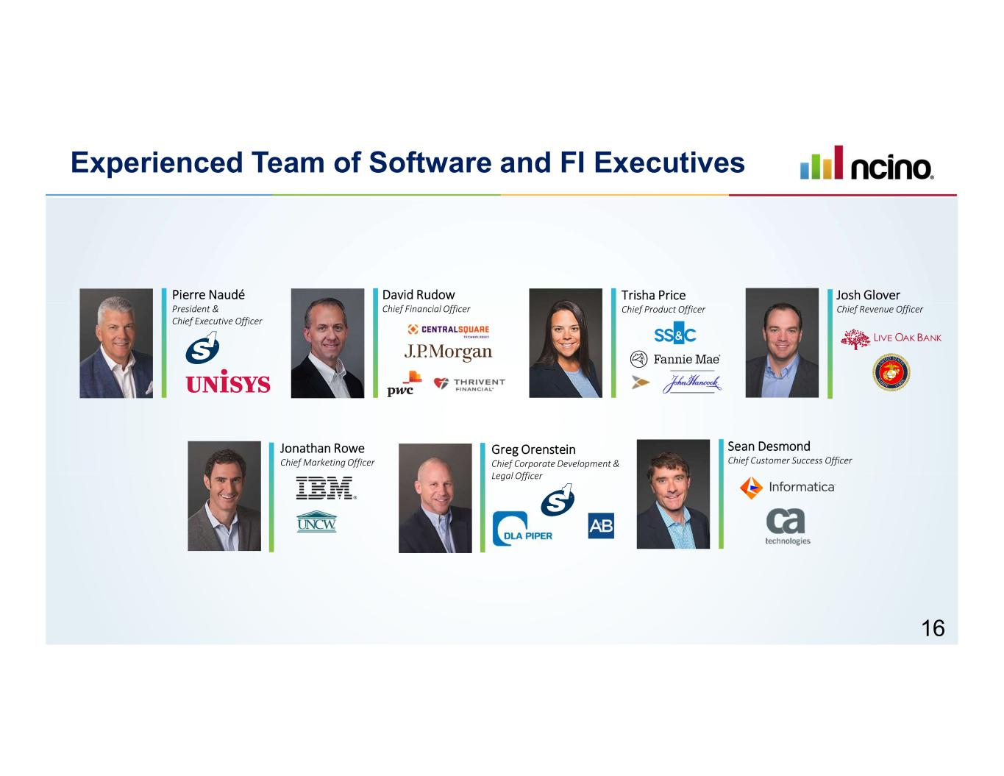
Experienced Team of Software and FI Executives Pierre Naudé President & Chief Executive Officer Jonathan Rowe Chief Marketing Officer Josh Glover Chief Revenue Officer Sean Desmond Chief Customer Success Officer David Rudow Chief Financial Officer Trisha Price Chief Product Officer Greg Orenstein Chief Corporate Development & Legal Officer 16

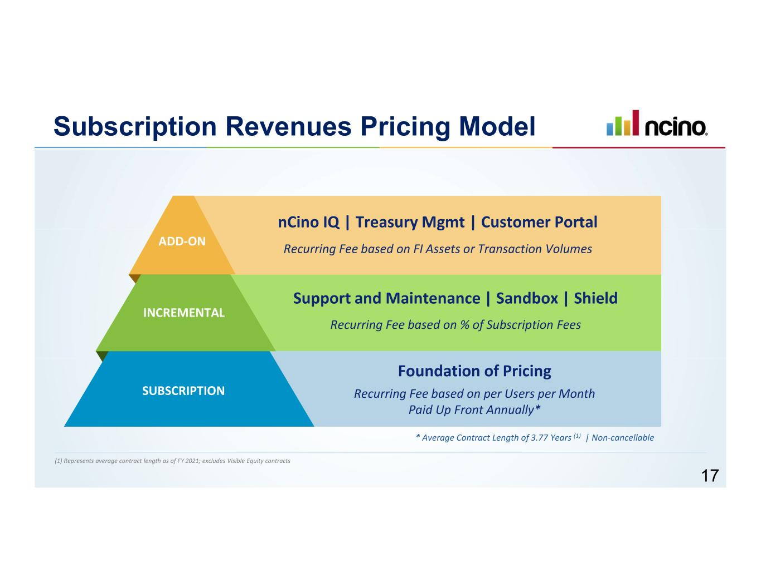
Subscription Revenues Pricing Model Recurring Fee based on FI Assets or Transaction Volumes Recurring Fee based on % of Subscription Fees Recurring Fee based on per Users per Month Paid Up Front Annually* SUBSCRIPTION INCREMENTAL ADD-ON Foundation of Pricing Support and Maintenance | Sandbox | Shield nCino IQ | Treasury Mgmt | Customer Portal * Average Contract Length of 3.77 Years (1) | Non-cancellable (1) Represents average contract length as of FY 2021; excludes Visible Equity contracts 17

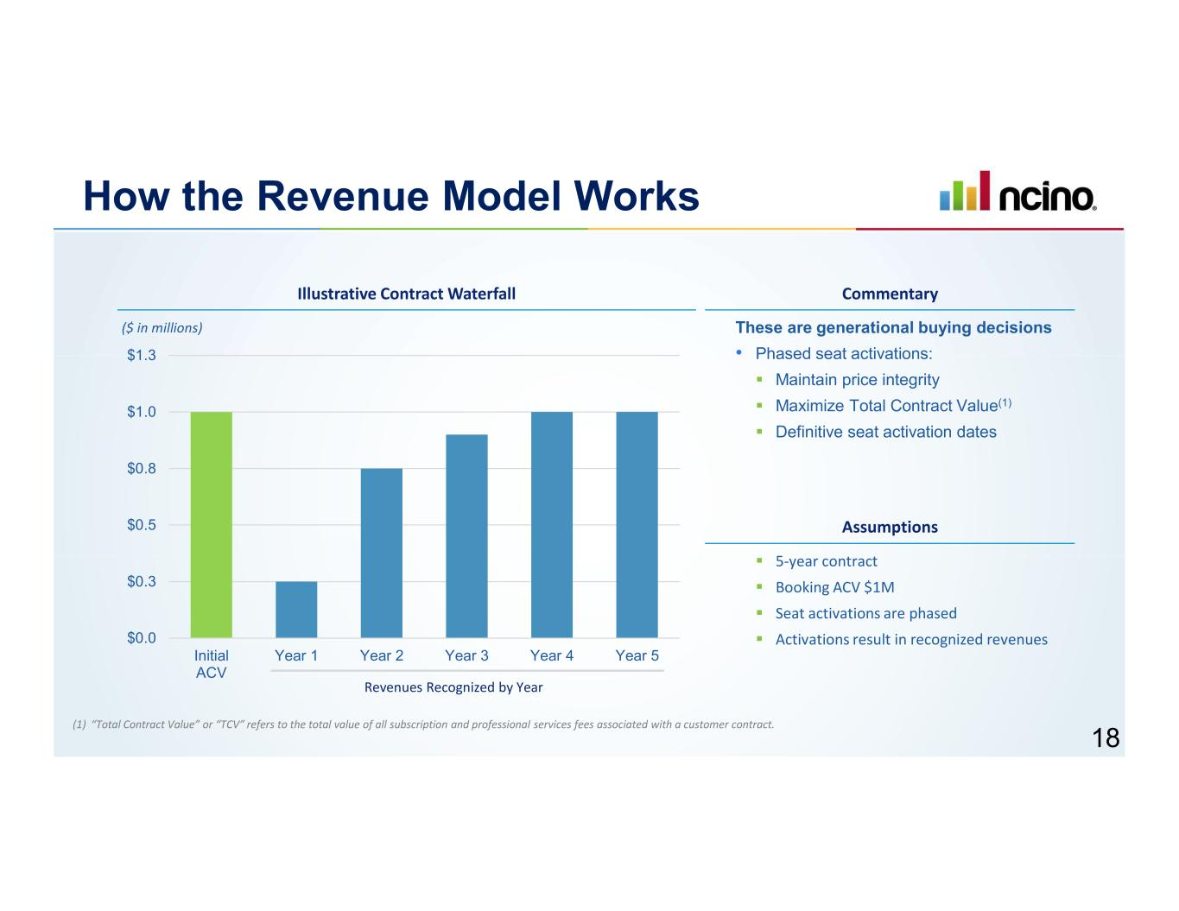
How the Revenue Model Works These are generational buying decisions • Phased seat activations: ▪ Maintain price integrity ▪ Maximize Total Contract Value(1) ▪ Definitive seat activation dates $0.0 $0.3 $0.5 $0.8 $1.0 $1.3 Initial ACV Year 1 Year 2 Year 3 Year 4 Year 5 Revenues Recognized by Year ▪ 5-year contract ▪ Booking ACV $1M ▪ Seat activations are phased ▪ Activations result in recognized revenues Illustrative Contract Waterfall Commentary ($ in millions) Assumptions (1) “Total Contract Value” or “TCV” refers to the total value of all subscription and professional services fees associated with a customer contract. 18

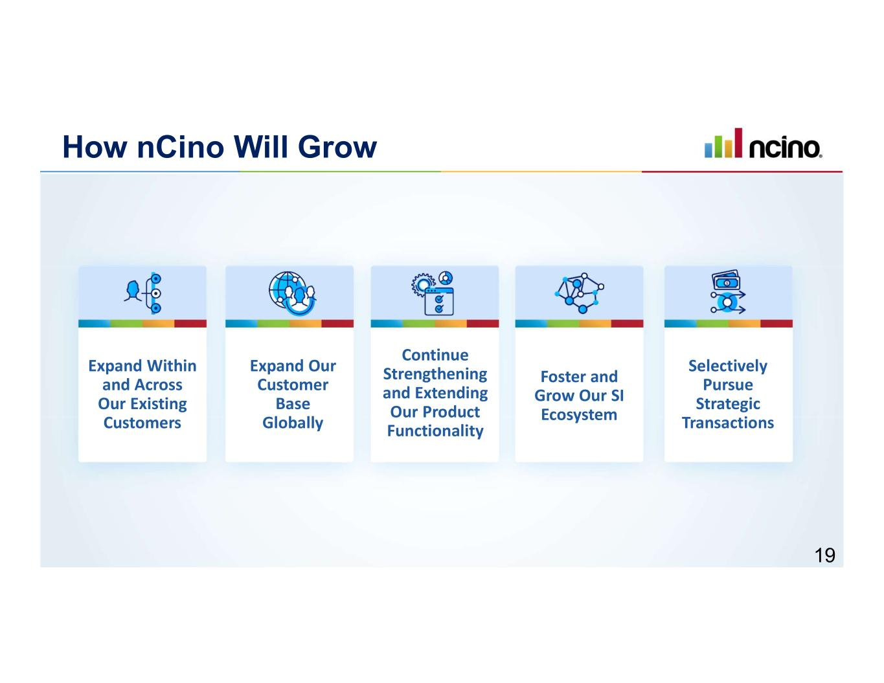
Expand Within and Across Our Existing Customers Expand Our Customer Base Globally Continue Strengthening and Extending Our Product Functionality Foster and Grow Our SI Ecosystem Selectively Pursue Strategic Transactions How nCino Will Grow 19

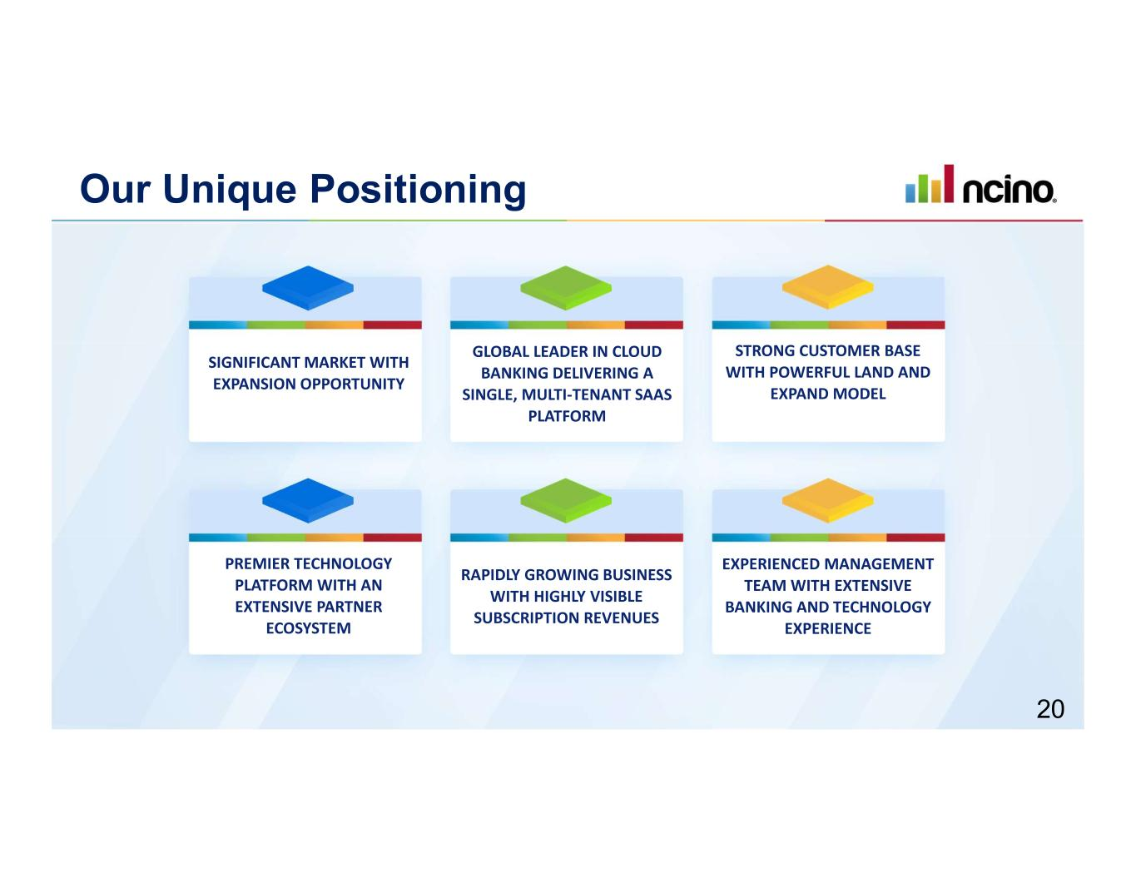
Our Unique Positioning SIGNIFICANT MARKET WITH EXPANSION OPPORTUNITY GLOBAL LEADER IN CLOUD BANKING DELIVERING A SINGLE, MULTI-TENANT SAAS PLATFORM STRONG CUSTOMER BASE WITH POWERFUL LAND AND EXPAND MODEL PREMIER TECHNOLOGY PLATFORM WITH AN EXTENSIVE PARTNER ECOSYSTEM RAPIDLY GROWING BUSINESS WITH HIGHLY VISIBLE SUBSCRIPTION REVENUES EXPERIENCED MANAGEMENT TEAM WITH EXTENSIVE BANKING AND TECHNOLOGY EXPERIENCE 20

